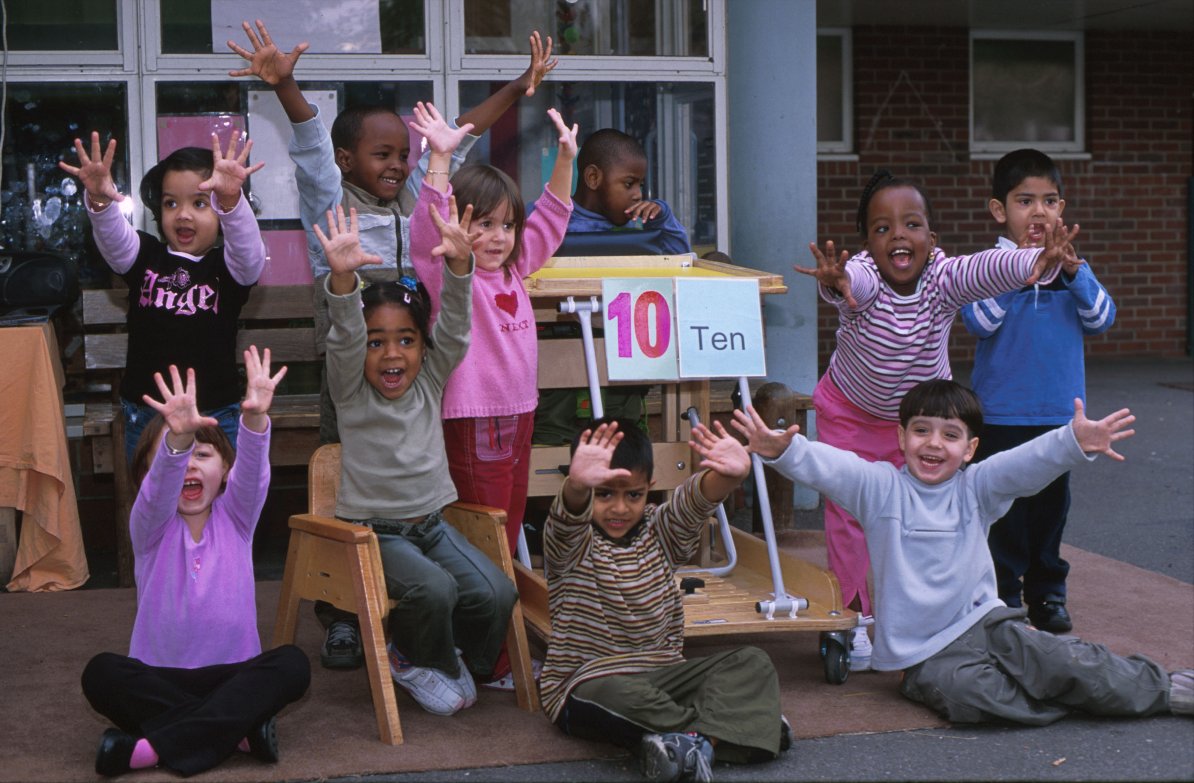
Counting Book

One to Ten
with BSL and the Braille System
All Equal
All Different

This book is part of the “All Equal All Different” Project providing disability equality resources for KS1 and Early Years.

The first ten counting numbers are shown through a series of colourful photographs. These numbers are written in Braille (non-embossed) and BSL.

For further information on Braille visit www.deafblind.com/braille.

April 2004

ISBN

Thank you to Cleves School. Copyright Carlos Reyes Manzo for Photographs and Disability Equality in Education For the Resource Pack Disability Equality in Education and the United Kingdom Disability Forum for European Affairs

First published by Disability Equality in Education and the UK Disability Forum for European Affairs with a grant from the Department of Work and Pensions for European Year of Disabled People.

(Back Page)

Copies available, as part of All Equal All Different Pack, from DEE- £75 including P&P

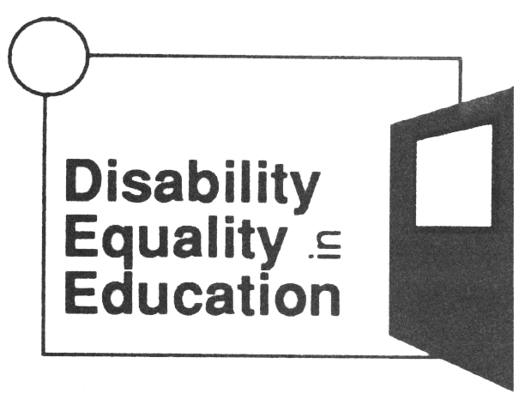 DISABILITY EQUALITY IN EDUCATION [Reg. Charity No. 1055287]
Providing Training, Consultancy & Resources To Develop Inclusion in UK.
to develop Resources to develop Inclusive Education in the UK
Unit GL, Leroy House, 436 Essex Road, London N1 3QP
Tel: 020 7359 2855 Fax: 020 7354 3372 E-mail: info@diseed.org.uk
Website www.diseed.org.uk

