Free Up Your Life
(East London Mentoring Project)

Index
 | Page
Foreword by Richard Rieser | 2
1. A Pen Picture | 4
2. Project Structure | 5
3. How the Program was delivered | 6
- Activities in the Mentoring Sessions  - Young People’s Dreams and Aspirations  - Independent Travelling  - Bullying  - The importance of Mobile Phones  - Activities outside School  - Discussing Relationships and Sex  - Development of Confidence and Self-esteem  - Other issues that arose | 7  7  9  11  12  13  13  15  17
5. Parents | 19
6. School Staff | 19
7. Promotion of Inclusion in Schools | 21
8. Conclusions and Recommendations | 22
Addendum – Your Turn to Talk Day  Appendix - Timetable of Activities | 31  42

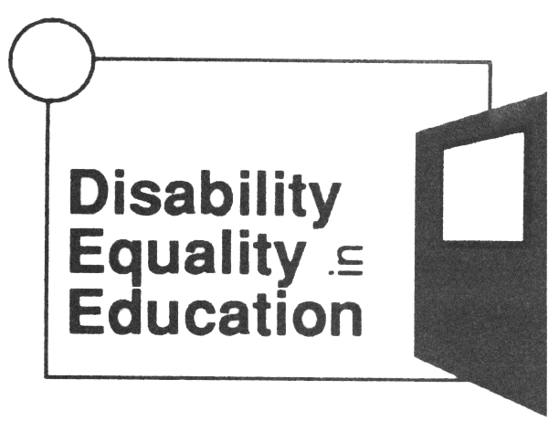
Disability Equality In Education tel: 0207 359 2855
Unit GL, Leroy House fax: 0207 354 3372
436 Essex Road e-mail: info@disee.org.uk
LondonN1 3QP website: www.diseed.org.uk
Registered Charity No: 1055287

Foreword

to
Free Up Your Life
End of Project Report

For many years disabled young people have been isolated and segregated in education. That has had an inevitable impact on their self-image.

In the last 25 years there has rightly been an increasing emphasis on integrating disabled students into mainstream schools. Now the SEN and Disability Act enshrines these moves in a rights framework for disabled pupils and students. Recently teachers and other staff have tended to focus on including disabled students in the curriculum and to a lesser extent the social life of the school. This is what the Government would call inclusion, and DEE spends much time training staff across the education system- more than 15,000 in the last three years. Our training is based on a rights based approach, which views disability as a social construct created by barriers of attitude, environment and organisation. Having a significant impairment leads to this exclusion, but it is not the cause.

What is often left out of this formulation is how disabled young people feel about themselves and how they should make sense of living their lives as disabled people. This pioneering project begins to open up these issues by providing disabled adult mentors to work with groups of young disabled people to develop self esteem and life skills. Often just being there - as confident, independent and professional disabled adults - opened up new horizons for the young people.

The project has thrown up a wealth of experience and insights about how to implement this process. This was just a pilot, but we already know (as do the teachers, staff and young people who were involved in this project) that all schools need such mentoring projects involving successful disabled adults as role models and mentors.

Disability Equality in Education would like to thank
- The Department for Education and Skills for funding this project
- the London Boroughs of Hackney, Tower Hamlets, Newham and Camden.
- We would particularly like to express our appreciation to the pupils and staff of East Lea, George Green, Langdon, Royal Docks, South Camden Community Secondary Schools for the collaboration and support that has made this project possible.
- Thank you to Christine O’Mahony for her patience, skill and determination in making this happen,
- and thanks to our mentors.

It is our great hope that the usefulness of such mentoring schemes will be taken up by the statutory sector, so that young disabled people can be empowered and equipped to live a full and inclusive life.

Richard Rieser, Director of DEE, March 2003.

Free Up Your Life

End of Project Report – March 2003

1. A Pen Picture

1.1 In May 2002, Disability Equality in Education (DEE) won a £30,000 grant from the DfES to set up a pilot mentoring project for disabled young people in mainstream schools in partnership with the education authorities in three London boroughs.

1.2 It was agreed that there would be two groups set up in each borough. Each group was to meet eight times before the end of March 2003 and activities would be loosely based around a curriculum that includes the following.
- Rights and Disability
- Getting about – How? Where?
- Getting Direct Payments and managing money
- Going out /going on holiday
- Dealing with bullying and name-calling
- Getting a job or further training – getting access to technology
- Living independently – getting accommodation
- Relationships with other people

1.3 Young disabled people were encouraged to involve their non-disabled friends in the groups so that a clearer understanding of disabled issues would emerge for them.
Many of the young people involved in the groups were labelled as having learning difficulties. Some had physical impairments and the groups spanned a wide range of access and communication needs.

2. Project Structure

2.1 Management
The Project was managed by Disability Equality in Education, via the Director, Richard Rieser, and the Trustees of Disability Equality in Education. Reports were made to the Director and Trustees on a regular basis, including a written Interim Report in December 2003.

2.2 Co-ordinator
A Project Coordinator was appointed to work on a 40-day contract from June 2002 – March 2003. The job description included: getting the project off the ground, contacting schools and educational authorities, appointing, supervising and supporting mentors, setting up mentoring groups in conjunction with the schools and overseeing the project generally.

2.3 Mentors
Fourteen disabled mentors were appointed but, in the event, only eight were able to take up the work. They came from a variety of backgrounds including teaching, youth work, community work, People First, etc. Two young mentors were new to the work but had the experience of being disabled in local special and mainstream schools. They also had experience of youth work. All mentors had undergone the DEE Training the Trainers course, which focuses on issues around disability and inclusion. Three training sessions were offered for mentors: one looking at the role of mentor and building relationships with young people; one looking at the proposed curriculum and how we could achieve it; and one looking at what we have learnt from the project.

3. How the Program was delivered
  - We started Free Up Your Life with conferences in two London Boroughs for young disabled people and their non-disabled friends. The planned conference in a third borough had to be cancelled due to a transport strike on that day and the low take up from schools. The Conferences were used to explain the project and included performances by disabled artistes. (Graea Theatre premiered their new play “The Trouble with Richard” at one Conference.) We also had drumming and story telling workshops, as well as discussion groups at both. We then went on to set up five mentoring groups in three different schools. The groups started meeting from the end of October 2002.

  - We approached a sixth school in January 2003 because we wanted to try out a different model of working with young people for comparison purposes. They responded enthusiastically and we arranged for a mentor to work one-to-one with two young people at the school, addressing the same issues as were addressed in the group sessions.

3.3 Number of schools contacted: 34
Borough 1 - All secondary schools 12
Borough 2 - All secondary schools 12
Borough 3 – All secondary and
- one special school 9
Borough 4 1

3.4 Number of young people contacted: 79
Conference 1: 30
Conference 2: 45
Borough 3: 2
Borough 4: 2

3.5 Young people who joined mentoring sessions: 38
School 1: 24
(two groups of 12)
School 2: 8
School 3: 4
School 4: 2

3.6 Number of Mentoring Sessions offered: 64
We met roughly fortnightly with disabled
young people in mainstream schools
for eight sessions per group.

4. Activities in the Mentoring Sessions
Each mentoring group devised its own specific activities within the limits of the programme as outlined in section 1.2. Each group differed in size, make up, personalities, impairment issues, and goals. Lead mentors negotiated plans with the groups and delivered the programme in a range of ways that included using: role-play; images; music; games; visual expression; discussion; and one-to-one sessions. At one School, a mentor developed a Snakes & Ladders style game that illuminates the barriers to inclusion and supports disabled young people’s encounters in home life, school life and social life.

4.1 Young People’s Dreams and Aspirations
My hopes and dreams
At two schools, art sessions were used with young people with learning difficulties to develop visual images of their lives and aspirations. Extensive work was done around the transition from school to college or work. Starting with an image of ‘hopes and dreams’, we were able to elicit the life aspirations of young people with learning difficulties and talk with them about their futures.

“The young people were very keen to talk about their futures. Some have already got transition plans in place; others seemed very hazy about what they are going to be doing after the end of school. One young person burst into tears and said she was very frightened of leaving, she thinks she will not have any friends and will not be going out at all. This led to a discussion of friends outside school. None of the young people see friends from school when they are at home. Social activities seem to be contained within the family with most of them quoting activities with a ‘cousin’ as the fun things they do. All but one of the young people saw themselves as continuing to live at home in the future. One confessed she would like to live with her boyfriend before marriage but she is not planning to tell her parents.”
Mentor

“Some things have been very exciting for them to look at, difficulties they have about leaving school and going into the world of work, learning to drive, etc.”
Teacher

The young people had reasonable expectations of life generally:

“A’s dreams are:
- to drive his own car,
- be able to take his mother to the shops and to the laundry,
- to go to college
- to get a good job”

“D’s dreams are:
- to have some friends visit him at home,
- for there to be more ‘wheelchair friendly’ sports at school,
- for every crossing and road to be ramped, “

together with some unreasonable ones:

- “to be able to walk on my own with no bars, sticks walkers, or wheelchairs.’”

The young person who aspired to the above lived in a family that had a very negative view of disability in terms of him, the schooling he could hope for and what he could achieve in life. He had a twin brother (non-disabled) who was able to fulfill all the family’s hopes and dreams for its children. It is not surprising that he would wish to be other than he was in that he had never received any positive validation of himself as a disabled person.

4.2 Independent Travelling
At one school, a wheelchair user wanted to think about being able to drive. He had not been aware that he could become an independent car user. His mentor took him out to her car to demonstrate how she got in and out of it. Up to that point he had assumed that he would always be dependent on family members for support with travel. The mentor explained about Motability and the Disabled Living Allowance. It was very important in this instance that his mentor was disabled. Having a wheelchair-using role model who is professional, earning good money, and driving herself around raised the possibility of an independent future for him. It is doubtful that a non-disabled person giving the same information would have had so profound an effect on his self-image.

“ A. had a completely unsuitable wheelchair. He was waiting for a new one from the local authority Wheelchair Service and had been for some years.
- I persuaded the Service to admit that he needs a lightweight high specification wheelchair suitable for an independent user and driver and he is now waiting for this.
- We applied to Whizz Kidz charity for a suitable wheelchair (This initiative moved the local authority wheelchair services to reassess him).
- We got A onto a wheelchair mobility programme, run by Whizz Kidz. With the help of young, fit wheelchair users he is learning a whole variety of skills: e.g.: doing wheelies; going up kerbs; and confidence in the street. He has been invited to join the youth wheelchair basketball training sessions.
- We are on our 3rd attempt to get him a driving license
- We are in the process of applying for financial help with driving lessons through the government scheme.”
Mentor

She also worked with another student who was struggling with issues around his self-image in relation to his mobility impairment:

We spent time looking at images and pictures of wheelchair users. On his request, I brought in my ‘wheelchair Barbie doll’. This sparked off a lot of talk about using a wheelchair and all the kinds of things you can do with your life, even if you don’t walk. D. uses a small, rather unstable, power scooter. Following a fall, he is nervous about getting around the school. He waits for his Learning Support Assistant and leaves each lesson early to avoid the crowds. We talked about increasing his independence. One day, when the LSA failed to turn up, we went together as two mobility-impaired people into the lift and along the corridors to the dining hall.
He discovered that:
(a) he could do it, and
(b) other students were helpful and would open heavy doors for him.

Many of the young people with learning difficulties complained about not being allowed/enabled to travel independently. This was a big issue for them. They asked that travel training be put on early in their secondary school careers so that they could travel to and from school with their brothers and sisters instead of having to travel on what one young disabled person called “the reject bus”. It is clear that there is a stigma attached to social services travel systems. Segregated transport systems make it very difficult for disabled young people to be completely included in the wider curriculum of the school as they are rarely able to stay late and join after school clubs, etc.

4.3 Bullying
A lot of work was done around bullying. One group used the transcript of the Graeae Play “The Trouble with Richard” to role-play issues around bullying and discrimination towards disabled young people. This was early on in the programme. A later session on bullying brought forth more detailed descriptions of bullying and information about bullying:

“Before splitting into boys and girls, two of us (mentors) admitted to having been bullies at school. We described what we did and what were the outcomes. We asked if anyone in the group had ever bullied someone and one person said he enjoyed following people and making them frightened. The group (most of whom had been at Special School previously) said that there was far less bullying going on their mainstream school than there had been at Special School. No-one had ever felt bullied personally, although they had seen others being bullied. They were full of praise for their teachers and said that they had never experienced bullying teachers in the mainstream, although this was common in the Special School they had attended.

In the boys’ group the discussion led to an understanding of what might be the causes of bullying, but no admissions of being bullied. The girls’ group discussed the different ways girls bully and boys bully and agreed that girls tend to pull hair, use bad words and hurt people’s feelings rather than kick and punch like boys do. One wheelchair user said she had felt bullied when she first came to the school as other children pushed her chair around and demanded rides on it. However, the teachers had explained about her personal space and she no longer had that problem.”

Mentor

One young person with Downs Syndrome talked about having been a bully in her special school. Others who had been there with her agreed that this was so and told her how scared they had been of her. She seemed to drift between pride at the idea that she had been a top dog for a while and shame at having frightened other young people. We talked about how people got into trouble for bullying and she recognised that it was wrong but nevertheless was semi-pleased with herself for finding a way to feel powerful in a world that treats disabled people as the bottom rung of the ladder.

4.4 The importance of Mobile Phones
We used ground rules agreed by the young people as a basis for discussion of a wide range of issues, including: having girlfriends/ boyfriends; money; friendships; being treated respectfully; not telling each other’s secrets; etc. An interesting way of getting at issues important to young people was to develop a discussion around the use of mobile phones. Issues that came up included:
- Relationships (girlfriends/boyfriends),
- Friendships (who calls who and why);
- Money (who pays your mobile bill, how do you handle money negotiations with parents);
- Crime (phone mugging, bullying by the phone, safety on the streets, etc.)

4.5 Activities Outside School
It was clear that most of the disabled young people we met in one school led very isolated lives outside. None of them met friends at weekends, except when they accidentally ran into each other at a community project for disabled young people. This was never pre-arranged or organised, it just happened. It was clear that these young disabled people are having a markedly different experience of teenager hood than their non-disabled peers. They all agreed they loved to shop, but none had ever been on a shopping trip with friends. One said that she had to go with her mother and this was a problem because her mother’s taste was very different from hers (old-fashioned). She would prefer to go with young friends who shared her tastes but this was not possible. There were also cultural implications to having a social life outside the home. We tried to get a sense of this by asking what older/younger sisters and brothers are allowed to do. None of them had access to the same activities as their siblings. We asked them if they would like to do the same things. They all said they would.

4.6 Discussing Relationships and Sex

We talked about relationships a lot. They were almost all interested in having a sexual partner and in developing long term relationships. The older young people (16+) tended to have a romantic view of relationships, expecting to meet ‘the one’, get married and have children at some point in the future. However, the younger young people (14+) at another school saw it more crudely in terms of sexual gratification and had less perspective on the right personality in a partner or on being in love. We talked about the models they had for love, marriage and romance, asking them questions about older siblings’ relationships, parents’ relationships, etc. This was important as their expectations were affected by their cultural backgrounds as well as by the fact of being disabled. Most of the young people were working class and/or members of ethnic minority groups. It was important that mentors did not impose white, middle-class or euro-centric values on their experiences and aspirations.

“This was a smaller group than usual and this led to a more intimate atmosphere that facilitated lots of discussion. What was remarkable was that it was so relaxed. Although we had intended to split into girl/boy groups this turned out not to be necessary as everyone appeared comfortable in the larger group and there was some benefit in hearing different genders’ viewpoints. Some of the young people talked about their relationships. T talked about his girlfriend and expressed his hopes for the future. M said that she had had a boyfriend at her previous school, but rarely saw him now. The fact that we were prepared to talk about our own teenage relationships increased their confidence in our integrity. They seemed to greatly value the opportunity to talk about such an intimate and important subject.”
Mentor
The young people talked about what would cause most estrangement between them and their parents. Issues that came up were:
- Getting pregnant (if you are a girl) (For some of the boys getting a girl pregnant would be appalling, but for others, it would be seen as a sign that they are a real man).
- Taking drugs (both groups)
- Getting a tattoo
- Leaving home
A similar discussion with a group of young people who had been educated in an inclusive borough throughout produced different responses. The boys seemed sure of their ability to attract girls and of their right to a sex life. They expected to be able to have relationships with non-disabled girls and said that in the past people had been “very ignorant” but that these days it’s different. The girls admitted to having had boyfriends and to an expectation of having several boyfriends before settling down.

“I think young disabled people in schools don’t see disabled adults. I think it’s really good. They were talking about sex and relationships. That’s the sort of thing that wouldn’t happen here otherwise.”
Learning Support Service

4.7 Development of Confidence and self-esteem.
Throughout the project we worked to develop the young people’s self-confidence and self esteem. Regular activities included getting them to say what they liked about themselves and each other and to introduce themselves “loudly and proudly”. At the beginning of the project this was very hard for some:

“We started with a round of your name, something you like about yourself and something you like about the person next to you. This went well enough, they loved having something positive said about them. There was lots of giggles and shyness and it was very hard to hear some of them. I was glad of the BSL interpreter’s help.”
Mentor
However, as time went on, the young people became used to this activity and looked forward to it.

“One boy was very, very reserved and when he first came to the group he wouldn’t even come up to the table and he just drove his wheelchair round and round but eventually he got brave enough and he came over”

Teacher

One person in particular, who was barely audible at the start of the project, was able to speak out confidently about herself by the end. Each session started with us asking them to tell us something that had happened since our previous meetings.

“One of the other children has very indistinct speech. He is a child you don’t usually hear from but one day, I could just hear this boy talking at the top of his voice, and it was a wonderful feeling.”
Teacher

The young people became increasingly eager to confide in us, “
I think they really enjoy discussing things now and being able to talk about their feelings much more.”
Learning Support Services

Feedback we had from the young people was “You really listen.” Listening well was very important. Most young people with learning difficulties are used to not being listened to and display a degree of hopelessness and acceptance of it. We made a particular point of showing that we were interested, that their viewpoint was relevant, that what they had to say was important and that they deserved to be listened to by us and by each other.
We attempted to model using good listening skills and made a requirement of the young people that they do the same. By and large they were sympathetic and supportive of each other but there were some difficulties. For instance, one young person had a huge yearning for a member of staff in the school. The others in the group were irritated, dismissive and disrespectful of this. A mentor reminded them that no matter how inappropriate the feelings and her expression of them might be, they were real feelings to her and she didn’t deserve to be laughed at or told off about them. After that, group members became gentler with her around the issue and she became less insistent about displaying her feelings.

“I think there probably has been a change. I think gradually young people in this group have got more confidence about things and a bit more open.”
Learning Support Service

Other issues that arose
Some issues were outside the remit of the programme but nevertheless are worth a mention:

4.8.1. Refugee Status
At one school, the mentor worked with a young refugee who needed a lot of practical help:

“He is a refugee with leave to enter the country, but not leave to remain. He does not have a passport. His father is not in this country and he is the eldest of the three children. He feels a responsibility to be the ‘head of the family’. He is a wheelchair user who has had an impairment since birth.

It is clear that there are a number of practical things that I can help with. Social Services provision is difficult to understand at the best of times and there are extra complications because of the family’s uncertain status as refugees. Because of the problems with his status in this country, I have agreed to liaise with his solicitors. I have also given him advice on a number of issues related to his educational goals.”
Mentor

The mentor voluntarily continued her relationship with this young man after the end of the project. “There are a number of things we have started but not completed, I will continue to work with him until the things we started have been sorted out.” It is clear that this level of commitment will make a difference to this young man’s ability to manoeuvre through the system for disabled people in the UK.

4.8.2 Disabled Identity
“F. explained to the group who Ian Drury was and about some of his history and beliefs. She said that he was a disabled man. I interjected and asked if they knew what disabled meant. They had no idea and had never heard the word before. We then had a discussion about disability. We both used our own experience of disability incorporating the Medical/Social model. They seemed to understand the concept. We asked if they thought they were disabled, they said ‘no’.”
mentor
There were similar discussions in other groups. It appears that, in an effort to protect the young people from disabled people’s oppression, schools have omitted to help them identify themselves as disabled and take on the political and powerful perspectives in relation to the social model of disability. It is doubtful that this perspective would be taken on so unquestioningly in relation to other oppression.

At one school, the mentor asked the group if they thought they were disabled. They all said “no” so she checked out who the group did consider to be disabled.

“The group agreed that all the mentors (one deaf, one blind, one mobility impaired) were disabled but did not agree that they shared the identity with us. I explained that being disabled is not so much what your body looks and works like, or how your mind works. It is about the way you are treated because you have an impairment or label. I told them that, because I am deaf, I often have to ask people to repeat themselves several times. By the time I have asked three times, I get treated as if I am stupid – with scorn and irritation. This example proved to be key for the group (who all had the label of learning difficulties). One burst out “I’m treated as if I’m stupid and it makes me really angry.” Others joined in on this. They eventually understood that disability is a social concept rather than a medical condition and were able to apply this thinking to themselves and to their experiences.”
mentor

5. Parents
5.1 We met with four sets of parents over the course of the project. They were all very concerned about their young people and their futures. One set of parents told us that they had had no idea their child had a learning difficulty before the educational psychologist diagnosed it. To them she had always seemed, and continued to seem, as intelligent and able as her older sisters who are both at university. They could not see any difference between her and them.

5.2 The parents were pleased to meet with disabled adults who had status and who were providing a role model for their young people. They wanted to discuss the finer points of transition with us, although we were not really qualified to do this. We worked mainly around the idea of not having closed expectations of their young people, pointing out that we know disabled adults with all sorts of qualifications (including people with the label of “learning difficulties” who have degree level qualifications) and that what was true at one point in someone’s life would not necessarily be true at another. Although there wasn’t enough time for this in the pilot project, more in depth work with parents would be beneficial.

6. School Staff
6.1 The mentors endeavoured to develop good working relationships with school staff and by and large this worked well. Once the groups were established, we were welcomed into the schools and accommodated quite well.

“When I heard about it, I was so pleased. We really need this kind of group for our students. We feel we are working on our own - a bit isolated. Any support we can get from outside is good. “
Teacher
6.2 Wherever possible, we made a point of being available to talk to staff before and after sessions and give them information (whilst respecting individual’s confidences) about what we had been doing with the young people. Staff expressed appreciation of the work we were doing and reported that it was making a difference to have disabled people in the school.

“The work I do with young people is nothing like the work that can be done by someone who is disabled and who has been through the same experiences.”
Learning Support Service

“I wish it could always be here. I hope it will be here for a long time in the future. I do feel that if there is even one child that benefits from it, then it validates what is has done.”
Teacher
6.3 It was not always easy. One group was disrupted several times because of school timetable changes; strikes; the bus arriving early; and health issues of mentors; etc. Despite this, the group continued to function and grow.

6.4 Ratios of adults to young people needed to be high. One group had two young Deaf people so a BSL interpreter was used, one mentor brought a Personal Assistant - together with the three mentors, there was a total of five adults in the room. We have found that every adult was needed and useful to the process. Another group started with three adult mentors but went down to two, due to staff illness. At one School, the ratio was two mentors to what started as three, and rose to eight, young people. At Royal Docks, there were two mentors to four young people. At another the ratio was one-to-one. We had not realised how necessary this concentration of adults to young people would be but now understand that the intensity of the work fully requires this.

7. Promotion of Inclusion in the Schools
7.1 The original idea was to open the groups to disabled young people and their non-disabled friends. We also envisaged having the groups outside of school time but eventually had to adjust this for all the groups due to problems involved in staying after school for the young people. In the event, no non-disabled young people attended any of the groups. Reasons for this included the timetabling of the groups by the schools as well the lack of non-disabled friends.

7.2 Despite the absence of non-disabled young people in the groups, the mentors quickly came to realise that there were real benefits in meeting as a disabled only group. We worked towards helping disabled young people develop a sense of self-esteem and an awareness of their dignity and rights as disabled people.

“I think it’s been good for students to think about how included they are in the school and how they feel about it.”

Teacher

7.3 Had non-disabled young people been present, we consider it would have been more difficult to get them to open up about their real difficulties and issues. There could, however, be valuable work done in schools with non-disabled young people around awareness raising, inclusion and disability equality. Similar groups could be set up of non-disabled young people to examine their attitudes and practices around disabled classmates and friends. It would be useful to challenge ideas about who gets to go out with who, who spends break times where, who talks to who in class, etc.

8. Conclusions and Recommendations
8.1 This has been a very worthwhile pilot project in terms of developing disability equality and promoting disabled young people’s rights and dignity in mainstream schools. Our presence in the schools was very important to disabled young people. Many had never met a disabled adult and had no idea that we are able to hold down jobs, earn good money and take a full part in the wider community. One disabled adult has reported that when he was at school, the lack of disabled role models led him to believe that disabled people did not live until adulthood and that he could expect to die before reaching that stage himself. Eight recommendations are made below – the rationale for these recommendations are outlined on the following pages.

- That mentoring work using disabled mentors continues and is promoted and expanded to all schools
- That mentoring work with disabled young people in mainstream schools is taken on by the education service as part of its offer to the community.
- Disability Equality in Education Training is delivered to all school staff and students.
- In any future project mentors should receive regular one-ton-one supervision. This should include counselling about their feelings with regard to the work.
- A full-time co-ordinator should be appointed to each Borough.
- One to one time should be set aside to follow up issues that have been raised in larger mentoring groups
- School staff should not intervene in the mentoring groups unless it is absolutely essential.
- Mentoring groups should be staffed at a ratio of at least two mentors for every four young people.

Recommendation | Rationale | Comments
One:  That mentoring work using disabled mentors continues and is promoted and expanded to all schools. | All the schools we worked with supported the continuation of the project:  “I’d really like it to happen all the time – every week”  Young person  “It’s a starting point and it’s opened a lot of issues. “  Learning Support Service  “We need more regular sessions. It would be good to have it ongoing every week.”  Teacher  “I hope it can go on because it’s hard work. I think the young people didn’t realise what was involved. It’s not easy but it would be a shame if it came to a stop.”  Learning Support Service | It is important that mentors are drawn from the disabled community and that they have a strong identity as disabled people with a clear understanding of the social model of disability.
Two:  That mentoring work with disabled young people in mainstream schools is taken on by the education service as part of its offer to the community. | Establishing the Free Up Your Life groups proved to be much more problematic than we anticipated. Although the Project was devised as a partnership arrangement between three London Boroughs and Disability Equality in Education, meetings with Senior LEA officials were hard to initiate and useful communication with the individual schools was even harder. In an education service that is overworked and overstretched this is understandable and we appreciate that it was not from a lack of goodwill or intention, rather it was just sheer overload.  Despite strenuous efforts, we were unable to get anything other than an Assembly visit set up in one borough. In September 2002 the borough was in a transition period – moving from being managed by a private company a trust. It proved virtually on impossible to identify whom to target with information about the project. There were many staff changes and people were not responsive to our publicity or telephone messages. We did make contact and have meetings with head teachers and SENCOs at five different schools in the borough but were not able to negotiate the setting up of any groups. | It would be helpful to the project and to the young people if the schools were to ‘own’ the process themselves. We had to overcome people’s prejudice about visitors coming into the school and applying our vision. If the vision and the mentors were directly employed by the school there would be a more respectful response to the project generally and to the work we set out to do
Three:  Disability Equality in Education Training for all school staff and students.  Increased awareness raising activities for the schools generally. | We were surprised at the level of misunderstanding of disabled issues shown by some staff. For instance, one school told us that they never mentioned the word “disabled” because they didn’t want to upset the young people. This meant that we had to do a large amount of work on promoting the social model of disability in order to get young people to understand the issues at all. If staff had an understanding of this, it would help promote inclusion.  “We probably need to make the rest of the school more aware. It takes a long time to do awareness raising. We need to do more of it. We need to keep going. We need people to come in more regularly.”  Teacher | While all the schools we worked with could adopt the description of ‘inclusive’, there is a lack of understanding of the continual restructuring of policies, practices and procedures that is necessary to include disabled pupils in the academic and social life of the school to meet their fullest possible potential.
Four:  In any future similar project, mentors should receive regular 1:1 supervision. This should include counselling around their feelings with regard to the work. | We were under-prepared for the difficulties that arose for some mentors working with disabled young people in mainstream schools. A primary goal was for the mentors to form relationships with young people. One or two mentors found it hard to prioritise the forming of relationships over producing solid outcomes in terms of paper-based tasks, etc. One mentor became very depressed as he recognized his own issues in the young people and realized that, far from resolving them, he had merely put them behind him. Going to the school regularly was bringing him face to face with things he preferred not to think about.
Five :  A full-time co-ordinator is appointed to each Borough. The appointment might be able to come under Learning Support Services or the Connexions Service. | The one-day-a-week spent on coordinator time was inadequate. The coordination of such a complex project involves liaison with a wide range of agencies, staff, mentors, young people, parents, etc. and it is not realistic to run the project without at least one full time member of staff.
Six:  That one-to-one time is set aside to follow up issues that have been raised in the larger group | As the young people got used to us, they tried to deal with some of the painful issues in their lives. Sometimes the issues were not easily dealt with in a large group. For instance, one young man had had a series of deaths in his family and wanted to talk about it. He needed to be listened to for a long time but there was inadequate time available for this in a large group where everybody had to share the attention.
Seven:  That school staff do not intervene unless it is absolutely essential. This will help to build trust and respect between the disabled adult mentors and disabled young people | Disabled adults are easily undermined by the presence of non-disabled adults who tend to ‘take over’. As many disabled adults have themselves been treated badly in the school system, they may adopt a powerless position in relation to school staff who seem more confident of themselves. This is not helpful to the mentoring process  Some mentors were disturbed by what they saw of the relationships between staff and students. More than once, we witnessed young people being pushed, pulled and told off.  Initially we felt that staff were worried about being shown up by ‘bad’ behaviour on the part of the young people.  In some groups, this was quickly resolved when the mentors made it clear that they were able to deal with whatever came up. In others, it was an ongoing problem, with teaching assistants, etc. monitoring the groups and intervening as they saw fit. | Ideally, it would be better if school staff members were not in the room during sessions but this leads onto issues of ratios of adults to young people.
Eight:  That mentoring groups are staffed at a ratio of at least two mentors for every four children | This work requires a great deal of concentration, particularly if it is to be effective with young people with “learning difficulties”. It requires the presence of several adults in the room to ensure that everyone is listened to adequately to make the process work

ADDENDUM
Your Turn to Talk Day
Thursday 15th May 2003.

After the end of the Free Up Your Life Project we undertook a consultation exercise with disabled young people in relation to the Government’s Special Educational Needs Action Plan. It made sense to consult with young people who already knew us and as we are aware that the least listened to young people are those with the label of learning difficulties we specifically chose to work with them. The fact that the young people knew us made them less inhibited about offering information.

The Group consisted of 18 young disabled people from Years 10-13. They had a variety of impairments including 3 deaf pupils and several wheelchair users. All have the label “learning difficulties”. Some have only known mainstream schools, but the majority were at a Special School until they transferred to mainstream in Year 12. It was important to not have any Teaching Assistants or Teachers from the school present so the young people could feel free to give their honest opinions.

The ‘Your Turn to Talk Day’ was planned, delivered and reported by DEE disabled trainers/mentors.

The day focused on getting the young people’s opinions on what made a good/bad teacher and what made a good/bad school. We started by checking that they understand who runs the country. We explained that the people who run the country want to know what they think about their school experiences and want to make it better and easier for young people to learn.

PAPER PERSON - One young person drew two outlines of people on a large roll of paper. The young people were given different images of teachers and asked to say if they were a good or bad teacher and why. They then filled in the outlines with the images and added statements about them as follows:

‘The Teacher from Hell’
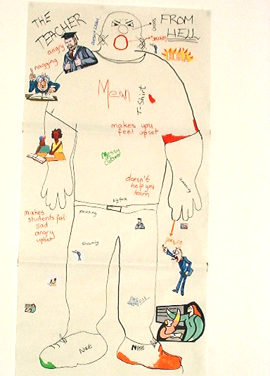
- Doesn’t listen.
- Is angry.
- Is mean.
- Nagging.
- Is cross.
- Shouting.
- Makes you feel upset.
- Wears messy clothes.
- Makes students feel sad,
angry and upset.
- Doesn’t help you learn.
- Screaming.
- Pointing.
- Wears trainers and
dirty clothes
- Has a big face

The Teacher from Hell

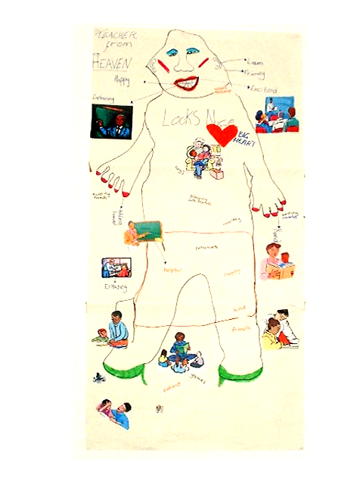
“The Teacher from Heaven”
- Listens.
- Is friendly.
- Is happy and exciting.
- Explains things.
- Holds hands with you.
- Is big hearted.
- Provides toys.
- Writes clearly.
- Lets you play with your
friends.
- Is healthy.
- Is kind.
- Is enthusiastic.
- Is helpful.
- Is patient.
- Looks nice and wears
make-up.

2. Working in smaller groups, the young people identified the characteristics of the “School from Hell” and the “School from Heaven”.
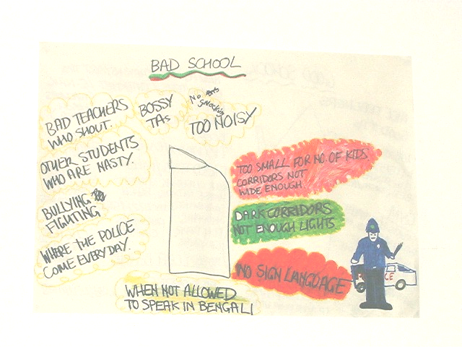
‘The school from Hell’:-
- Bad teachers WHO SHOUT;
- Teachers who swear, are messy, moody and very mean
- Other students who are nasty;
- Bullying and fighting;
- A place where you get pushed around in the playground;
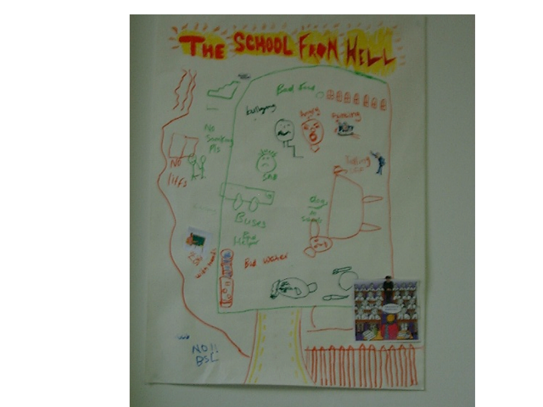
- Bad water to drink;
- The police come everyday;
- You are not allowed
to speak in Bengali;
- Bossy Teaching
Assistants;
- Too noisy
- Too small for the
number of Kids;
- Narrow, dark corridors;
- No British Sign Language ( BSL)
- Lots of stairs, no lifts and no wheelchair access;
- Bad or horrible food
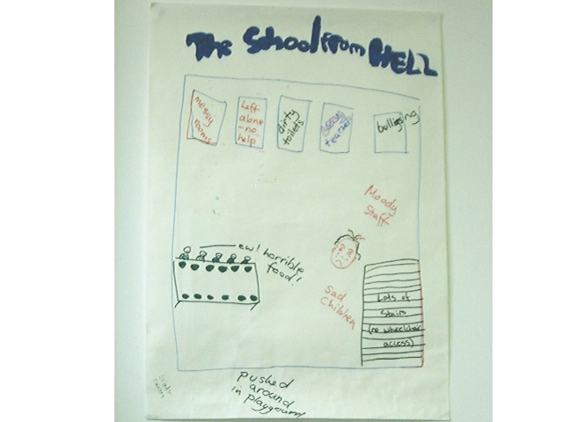
- Staff who are always leaving;
- Makes you sad
- Graffiti;
- A lot of smoking;
- Muddy grounds;
- Lots of homework;
- Lots of fires;
- Staff tell you off and point a lot;
- Is dirty, disgusting,
- Has broken windows
- Badly maintained;
- Small, messy classrooms;
- Leaves you alone with no help;
- Has sad children and students.

“The School from Heaven”
- Nice teachers who are polite, kind, nice looking and helpful;
- No paedophiles on the staff;
- Lots of facilities: kitchen, washing machines, microwave cookers, bed, dishwashers and dryers;
- Gym with sports equipment: balls, racquets, nets, rowing machine, cycling machines, treadmill, and swimming pool;
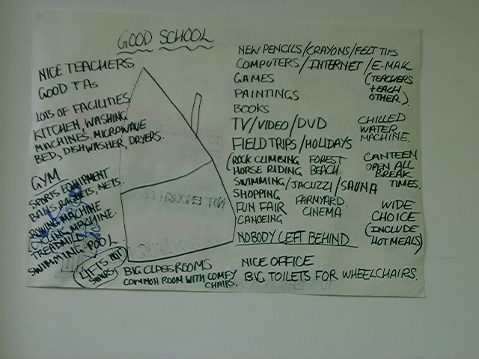
- Lifts, not stairs;
- Large toilets for wheelchairs;
- A good school nurse;
- Big clean, tidy classrooms
- New crayons, pencils and felt tips;
- Computers for all;
- Good Teaching Assistants
- Lots of books;
- All pupils and teachers on the internet/e-mail;
- TV, Video, DVD in each classroom;
- A lot of music and painting and games;
- Students’ common room with comfy chairs and an office;
- A playground like a park;
- Canteen open all breaks with a wide choice including hot meals;
- Good food and chilled water: e.g Fish and chips, KFC, Burger King;
- Well maintained, clean, well lit and decorated building;
- Good, happy kids with no bullying;
- School field trips/ holidays where nobody is left behind;
- Trips to include rock climbing, horse riding, swimming, Jacuzzi, sauna, canoeing, fun fairs, forests, beaches, shopping farmyards and cinema.

QUESTIONNAIRE

The young people were asked the following questions, individually and collectively.
- How has school helped you?
- What hasn’t been good for you at school?
- What do you think makes it hard for school to work well for you?
- Are there things you want to learn but you didn’t?
- What would make school better?

Responses
1. How has school helped you?
- School has taught me to work hard. It has helped me to make friends. It has prepared me for later life.
- My English is better than before. My writing is better. I am good at ICT. I have made friends. I like traveling to school in minicabs.
- Learning IT
- I have learned some new things, but not as much as I would have liked. I would have liked to learn about decorating
- School has helped me learn.
- Helped me read more. I like reading Romeo and Juliet. When I was at special school, I couldn’t read, but when I came here I could.
- Help deciding what to do - course knowledge.
- Help deciding what to do.
- Lots of people – work hard, happy here.

Science, Art and ICT
- Signing, English, IT and Maths
- PE teacher has helped me and Maths work.
- Hasn’t helped me.

2. What hasn’t been good for you at school?
- Nothing I would change.
- I haven’t learned things I will need in later life.
- Special school was worse than here. It was small. I like being in a big place. I like the people here. The teachers are better than at special school. We get different subjects.
- I don’t like being asked the same thing over and over again. Too much repetition. Some teachers think I’m not as clever as I am.
- I like the people. My friend helped me. She’s gone to college. I miss her. I understand what the teachers say to me, but they think I don’t
- Bullying and hair bullying
- The teachers don’t listen to me.
- Some teachers shout at me. More helpers in school.
- My friend left school. I miss him. Me and B go to the park
- Bullying
- Writing and English
- Arguments between teachers and parents, aunt and me.

3. What do you think makes it hard for school to work well for you?
- Sometimes when the work we are given is hard it is not explained well and when I ask for help the teacher tells me I have to do it by myself.
- Because I am quiet, other students who are noisy get more attention. I find maths hard to understand.
- Classes are too big (15). I’d like it to be 4 in a class. It is helpful to have a teaching assistant working with me. Three of them are nice to me. Some things are not explained very well.
- Cooking
- Doing work. Too much homework for me
- Doing some hard homework.
- Some teachers don’t understand me (BSL user)
- Not enough time. Classes too big (20). Would like 10. (I teacher and 2 TA’s).

4. Are there things you wanted to learn but you didn’t?
- I would have liked to learn to swim. I would have liked to know about how I could learn to find a flat or house to live in later on. I need to know more about how to manage when I leave school.
- I want to learn to write better before I leave. I would have liked to learn to swim.
- I think I’ve learnt enough here. I’m going to go to college to learn to look after babies when I leave.
- I don’t know what I think I need to know about making babies
- ICT
- I’d like to learn more about how to manage money. Would like to learn how to travel on public transport. I would like more training courses e.g. computers.
- I want to learn to drive.
- I want to learn more maths.
- I want to learn to speak Spanish. I speak English and Ethiopian.
- I want to learn more about everything.
- I want to learn more about money and time.

5. What would make school better?
- Teachers who don’t get angry quickly. For the school to have a swimming pool. School would be better if everyone worked hard and paid attention to stop teachers getting annoyed.
- It would be better if those of us with complex needs could mix with the whole school rather than be separated away.
- I think I would learn better if I went on more trips. When went to the London Eye, I learnt a bit about traveling on public transport and more about London.
- Doing more painting. We only do Art twice a week. More help with what happens after I leave school. I want to work in MacDonalds. This is my choice, but I am not sure if I will be able to because of my health and how quickly I can work.
- Get lots of friends.
- If I tried more. I could do more myself. I’m not a baby. I would like to be allowed to do more on my own (E.g. travel).
- If the teachers understood our problems better.
- When the teachers listen to me.
- If there were more teachers.
- All the teachers could sign. They could communicate with me. I would learn more.
- I want Free Up Your Life Again (DEE mentoring project) and the Reception.
- I’m going to do childcare.
- I’m getting married next year. I’m going to work after marriage and be a child care worker. I also want Fee Up Your Life ands Reception again.
- I want to leave.

Commentary
These young people would have experienced well over 100 teachers in their time at school. They have very clear ideas of good and bad teachers and what constitutes a good school and a bad school. We can identify a number of dimensions:
- Staff must be kind, enthusiastic, patient, helpful, good at what they do, well presented, and not shout.
- The school must be accessible for all including BSL.
- The school must be well equipped and maintained.
- The facilities must be accessible, well resourced and technologically up to date.
- The students must be treated well, not be bullied, be happy and have good food, drink and comfortable surroundings.
- The trips policy must include everybody and go to a variety of interesting and fun places.
- The PE and sports should have equipment more like an adult sports centre with a wide variety of activities and there should be a swimming pool.
- The curriculum should be well supported by books, equipment and be taught so all can understand it.
- Learning and being at school should be fun.
- Students prefer mainstream to their previous special school.
- Students want teachers to listen to them more, explain work and to have more teaching assistant support.
- Students want more help with transition to adult life.
- Students want to be taught practical life skills-travel, money, child care, driving.
- Students want all teachers to learn British Sign Language.
- Students want teachers not to assume they can’t do things because they are disabled.
- Students want to be taught in smaller classes with more support.
- Students want more flexibility in the curriculum so they can spend more time doing the things they like and are good at.
- Students with complex needs don’t want to be in a unit , but to mix with all the other students in the whole-school.
- Students don’t like bullying or shouting teachers.

Chris O’Mahony and Richard Rieser

APPENDIX ONE

Free Up Your Life timetable of Activities involved in setting up the Project
Date | Activity | Results
April 2002 | Recruit & appoint Project co-ordinator for 1 day per week over 40 weeks | yes
May 2002 | a) Co-ordinator starts work  b) Recruit and appoint mentors  c) Set up meetings with partners  d) Devise publicity for the project | Initially, ½ day per week .  - recruitment letters sent out to DEE disabled trainers. Twelve mentors appointed.  - Disappointing response to efforts to set up meetings with partner  - Initial publicity designed.
June 2002 | a) Co-ordinator starts working 1 whole day per week on the project.  b) Meetings with partners  c) Meeting with Mentors | yes  Meetings were set up with partners in three boroughs. Only one took place  - First training session with project mentors. Agreed to name the project Free Up Your Life.
July 2002 | a) Send out publicity  b) Letters to parents  c) Recruit and appoint more mentors  d) Letters to headteachers  e) Book conference spaces  Book entertainment for conferences  Establish who to invite to conferences  f) Meetings with partners | Publicity directed at young people went out to all schools in the three boroughs.  - Letters were drafted to parents and sent to partners to be passed on via the schools.  - Two more mentors were appointed  - Letters sent to all secondary headteachers and SENCOs in the three boroughs  - yes  - Meetings with Newham and Tower Hamlets education services.
August | a) Send out publicity to parents, heads, young people | a) A second round of publicity was sent out towards the end of August so that it would be picked up as soon as schools re-opened in September.
September | Training event for mentors  - Meetings with key people in schools  - Individual meetings with mentors | yes  - These were extremely difficult to establish despite numerous phone calls, and requests. Eventually managed to meet one partner. No meetings with partners from other boroughs.  - yes
October | Launch conference for borough 4  - Launch conference for Boroough 1  - Launch conference Borough 2  - Mentoring groups to start week beginning 28 October.  e) Further meetings with schools | Cancelled due to transport strike and low rate of response to publicity. Schools encouraged to send young people to Borough 2 conference instead  - Yes – 30+ young people, plus 12 adults present.  - Yes – 40+ young people present (including two from Hackney), plus 16 adults.  d) Assembly at one School.  One Group started  - Meetings with six organisations
November | Mentoring Groups meeting fortnightly | Five groups meeting
December | a) Mentoring Groups meeting fortnightly  b) Ongoing group and individual meetings with mentors | Five groups meeting  b) yes
January 2003 | a) Mentoring Groups meeting fortnightly  b)Sixth School involved | a) Five groups meeting  b) One-to-one mentoring sessions started with 2 disabled young people .
February 2003 | a) Mentoring Groups meeting fortnightly  b) End of Project Training session for mentors | 5 groups and one 1:1 session running  b) yes
March | End of Project Presentation at Free Up Your Life reception. Including press coverage | Two 1:1 sessions running  Young people on the project invited to reception to discuss outcomes of the project.

See Appendix 1 for details of activities involved in setting up and delivering the programme.
See inside front cover
see inside page cover
see inside front cover for example of publicity
See front and back covers
see inside back cover
See inside back cover
Reports of bullying began to emerge later in our relationship with the young people. They talked about being followed in the street and sneered at by other young people for using the “transport”. Some said they were frightened to go in the playground. There was a sense of acceptance and inevitability about their statements.
see inside front cover
see inside front cover

