Examples in the news
“Crippled and Deaf-Dumb make jewellery in spite of handicaps”
“About 30 crippled, deaf, dumb and blinded poor people have started a jewellery workshop on the east side of Harambee Plaza. They cannot walk or sit straight, most of them, and many used to be beggars.

Now, with all their problems and miseries between them, they will try to ignore their ugly fates and fashion something beautiful. With utmost patience and cheerfulness, they sit all day long putting together
necklaces, bracelets and rings to appeal to passers by. To help them feel worthy, perhaps some charitable people would buy these trinkets”.

What is wrong with this account?

“Crippled” and “Deaf-dumb” are out of date, derogatory terms. “In spite of handicap” is patronising and reproducing a common stereotype portraying persons with disabilities as victims who are generally unable to work due to their impairments. This approach focuses on inabilities rather than the many abilities that people have. The workshop is in this example described in pitiful terms, placing all the emphasis on physical conditions rather than on the workers skills and products. The necessary skills to produce
jewellery do not include walking or sitting straight. The article has very few facts, it mainly reveals the writer’s prejudices and assumptions that life with a disability is a tragedy.

How could have been written
New jewellery shop opened by disabled workers
“About 30 adults with various impairments such as paraplegia, blindness, deafness and amputees, havestarted a jewellery workshop on the east side of Harambee Plaza. Following six months training in necessary skills, they produce 30-50 original necklaces, bracelets and rings a day in modern and traditional styles.

Mr Sharif Mousaka, the workshop manager who uses a wheelchair, says, “Some of us used to be beggars and we are now trained to support ourselves and help support other family members. Our jewellery is well designed, beautifully made and competes with other products on the market”. Mr Mousaka also says that any customer who brings a copy of this article will be given a discount on the first purchase”.
Example 2
The Review: «Remix Dance Company shines with
fluid, graceful performances from talented quartet»
“Establishing a professional dance group integrating physically disadvantaged people dancing alongside able-bodied ones - as Remix Dance Company is doing - may perhaps be belated, but it is a vitally
important step towards empowering those with some infirmity to meaningfully participate in theatrical productions. And when a choreographer of Adam Benjamin's lateral thinking writes a work of the beauty and sensitivity of his Second Time Broken he unequivocally endorses the Remix Dance Company.

Nicola Visser and Mpotseng Shuping are not in any way handicapped. They are both attractive and technically efficient dancers. But Andile Vellem is deaf and Malcolm Black, in a wheelchair, has a rare disease affecting muscle control and speech. Yet Benjamin, building and capitalising on their strengths rather than dwelling on the duo's weaknesses (particularly Black's more obvious one) created an emotive state-of-the-art piece.

Making Katherine Glenday's delicate porcelain vessels the focus of his theme "only if you let go can you come back to me" Benjamin uses Neo Muyanga's earthy rhythmic sounds to weave graceful fluid port de
bras and inventive upper body movements into artistic choreographic designs. This grace was wellreflected by the quartet, as well as Paul Abrams's aesthetically pleasing lighting plot and Hannah
Leventhal's simple white flared pants and tops.

Ina Wichterich set the evening's opening number I Can't Give You Anything But Love to music by Billy Holiday and Muyanga.

Unfortunately, her awkward unrelated sequences emphasised Black and Vellem's frailties and didn't offset these by harnessing and showing Visser and Shuping's skills to advantage. Thus, it wasn't surprising that several patrons, not expecting that Benjamin's Second Time Broken would prove a gem, left at interval. Be sure not to do the same”.

(Review by Sheila Chisholm, published in the Cape Times, South Africa, on the 6th of February 2006.)
Firstly underline the inappropriate or deeming words in this review and then find alternatives using the Hacked Off Guidance.

Example 3

Doctors refuse mother's request to remove disabled daughter's womb 'because of charity backlash'
Last updated at 23:23 17 January 2008

A mother has lost her battle to have her severely disabled daughter's womb removed.
Alison Thorpe had hoped surgeons would operate on 15-yearold Katie, who has cerebral palsy, to prevent her from the "pain, discomfort and indignity" of menstruation.
But disabled rights groups said the teenager - who cannot walk or talk and is incontinent - would be put through unnecessary pain.
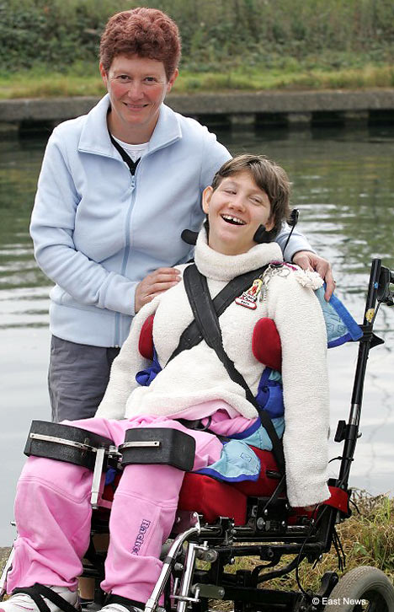
Yesterday it emerged that doctors have told Miss Thorpe, from Billericay, Essex, they would operate only if there was a medical reason to do so.
"This means that if and when Katie does start her periods she could endure months and months of pain and discomfort before anything is done," she said.
Katie's plight echos the controversial case of nine-year-old Ashley X in America who underwent breast bud removal and hormone treatment to keep her in a child like state, small and manageable for her parents who care for her.
But Miss Thorpe believes the Mid-Essex Hospital Services NHS Trust has been swayed by the outcry from some quarters, including the cerebral palsy charity Scope.
She said: "I think the Trust has bowed down to what they perceived to be public opinion.
"But I have had overwhelming support from the public, both able-bodied and disabled people.
"The only opposition has been from disabled rights movements but I would say to them, 'Come and spend a week with me, walk in my shoes'. I've spent 15 years with my daughter, as a mother who loves her dearly I am trying to do the best I can for her.
"I think the Trust has bowed down to what they perceived to be public opinion, that is my personal belief. I have had overwhelming support from the public, both able bodied and disabled people.
"I feel the trust misread the so-called lack of support from the minority, groups such as Scope.
"I have not had any contact with any (disability) organisation, they do not know me or Katie. They have not provided any support or help for us as a family.
"I am not surprised by what they said but in in the way they said it. They have not been made aware of any of the facts in his case, they made up their mind before hearing the other side of the story, without referring to us.
"I don't want to take away disable people's rights, I want to give them choice."
Doctors initially suggested contraceptive pills and injections to stop Katie's periods but Miss Thorpe ruled them out because of the risk of thrombosis for her wheelchairbound daughter.
Consultant gynaecologist Phil Robarts, from St John's Hospital in Chelmsford, had discussed the options with Katie's mother.
Miss Thorpe hoped doctors would also remove Katie's appendix as it might not be apparent if she suffered appendicitis.
The Trust now says it cannot justify surgery on the grounds suggested by the mother.
However, Miss Thorpe, who lives with partner Peter Reynolds, 52, and has another daughter, 12-yearold Melissa, has written to the Trust's non-executive directors asking them to put a plan into place to operate as soon as Katie starts her periods.
She added: "It's one of those things, life with a disabled child is one long battle and this is just another step down the ladder."
"It was not unexpected. It means we move to stage two and carrying on fighting."
Sharon Collins, an executive director at Scope, said: "An irreversible procedure of this nature that is not clinically necessary is not the right way forward."

