Music Choices and Rights The Music of the Disability Rights Movement
http://vids.myspace.com/index.cfm?fuseaction=vids.Channel&ChannelID=273532537
rough sound with great images from 1992 live at the Lincoln memorial dc
Pride
http://www.myspace.com/johnnycrescendo- videos-pride
Johnny Crescendo
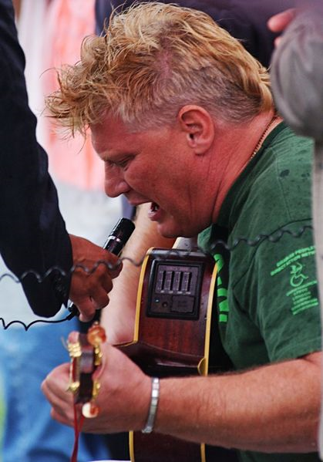
Johnny Crescendo, British balladeer for disability rights
By Mike Ervin (Mervin4241@aol.com)
Alan Holdsworth became Johnny Crescendo basically as a joke.
"It was during the punk era," he says. He was reading poetry and doing stand up comedy in clubs in Britain and one day he gave himself a stage name. "It was a piss take of the working class Latin lover singing 'My Way' in a dive with too much reverb. Suddenly I was getting loads of gigs and the name stuck. I was almost Sammy Scrabble or Tony Monopoly."
By either name, Johnny Crescendo is one of the strongest British voices for disability rights in both spoken words and music. At the gatherings of the hard core direct action disability rights groups, ADAPT in America and Direct Action Network (DAN) in Britain, he can often be seen up front playing his guitar and singing his homemade songs. His long repertoire of disability-themed songs includes sad ballads of people trapped in institutions, satires of the charity mentality and proud anthems of empowerment.
Though Johnny works by day as a policy advisor to the city council of his hometown of Birmingham, the action of street-level activism suits his passionate personality best. He claims to have been arrested over 100 times for civil disobedience, once was when DAN members blocked traffic outside Buckingham Palace. "Don't mess with the Queenie!" At night at ADAPT actions, when work is done, he can often be found in the hotel bar, smoking, drinking and laughing it up.
Growing up
Johnny's shoulders are broad and his arms are muscular. He gets around by pushing a manual wheelchair. He was born in 1952 in the town of Salford in the Northwest of England "There's a song called 'Dirty Old Town' about it. We were poor. My father was an electrician, my mom a secretary. My father died of cancer when I was 10 and we got poorer."
He went into the hospital when he was nine months old for cleft palate surgery. "I got polio, caught it in hospital but we couldn't sue. Suing is a rich person's privilege in Britain. If you lose the case you pay the costs which meant losing everything my parents had."
But the attitude of his family toward his disability, he says, was "pretty good considering the time. I went to a mainstream school throughout. When I was about 11, I went to senior school and I was bullied and started truanting. I left school at 16. I was bright but hardly a good student. Not being at school meant I began to self teach at an early age.
Published at 14
"I have always sung since I can remember. I started writing poetry when I was 12 and was published when I was 14. I really enjoyed it. I started writing lyrics for a friend who played guitar, then I learned how to play on my own from a book. I did my first gig about four months later with two songs: 'Colors' by Donovan and 'I Had a Dream' by John Sebastian."
The early songs Johnny wrote were mostly about racism, poverty or love. It took him 15 years before he wrote anything directly about disability." "First I just wrote a couple of humorous poems. One was called: 'Where dya Get that Leg?'. The other, 'Taxi Driver's Treat,' is an anti-charity poem."
His musical evolution coincided with disability revelations that would send him toward his political activism. "I was working in Chesterfield in the north of England as a youth worker and one of my workers, Izzy, challenged me to work with people with learning difficulties. I was reluctant but after about a month I realized that these people had just as many issues to deal with as the black young people I had been working with. We set up independent living for over 200 people in the next three years. That small first group of young people remains my reference point to this day".
Birth of DAN
DAN 1 http://www.youtube.com/watch?v=ngkx8ASyWaY
DAN 2http://blogs.myspace.com/index.cfm?fuseaction=blog.view&friendId=273532537&blogId=480103791
DAN3 http://blogs.myspace.com/index.cfm?fuseaction=blog.view&friendId=273532537&blogId=480103931
DAN 4 http://blogs.myspace.com/index.cfm?fuseaction=blog.view&friendId=273532537&blogId=480104025

DAN and the Fight for Disability Rights
The Direct Action Movement started in 1992 when like minded disabled people got fed up waiting for the UK Parliament to introduce legislation to ensure civil rights for disabled people in the UK. There was a majority in the House of Commons but the Conservative Government thought it would be too expensive and too much of a burden on business to impose legal rights for disabled people. They preferred to rely on the good will of business. Disabled People kept pointing out the systematic discrimination against disabled people that needed ‘comprehensive and enforceable civil rights legislation’.

The disabled people who came together in the Disabled People’s Movement had challenged the dominant view of disabled people.

The Medical Model of disability that being disabled arose from a loss of physical and/or mental capacity and that this was a tragedy that could only be compensated for by acts of charity and medical support.

They had a different view which united them what ever type or degree of impairment they had whether blind, deaf, wheelchair user, epileptic, learning difficulty or mentl health issue. The supported the Social Model of disability. They recognised that what stopped them participating and enjoying life was not their impairment, but barriers in society. Barriers of attitudes and belief, barriers in environment such as inaccessible buildings, transport or communication and the barriers of organisation.

For more to understand these different views of disability see:-
http://www.worldofinclusion.com/res/qca/Impair.doc
http://www.worldofinclusion.com/res/qca/Social.pdf

There is no doubt that the Direct Action Network and the publicity on TV and support they generated from the public put pressure on the Government. So on the 17th attempt the Disability Discrimination Act was passed into law. However it was very weak with many gaps.
Lord Lester a well know Civil Rights Lawyer described it ‘more like a leaky sieve than a piece of human rights legislation’. The Labour Party made Enforceable and Civil Rights for Disabled People a Manifesto commitment in the 1997 Election.

Once they came to power they set up a committee of enquiry of disabled people and leaders of business, trade unions and small businesses. They came up with 150 recommendations. The most important of these was to extend the DDA to cover all education and this was passed into law in 2001 SEN and Disability Act. The other measures included covering all goods and service providers having to make permanent adjustments for all disabled people and extending rights at work to all employers whatever the size and introducing end dates when all new buses, trains have to be accessible to disabled people.

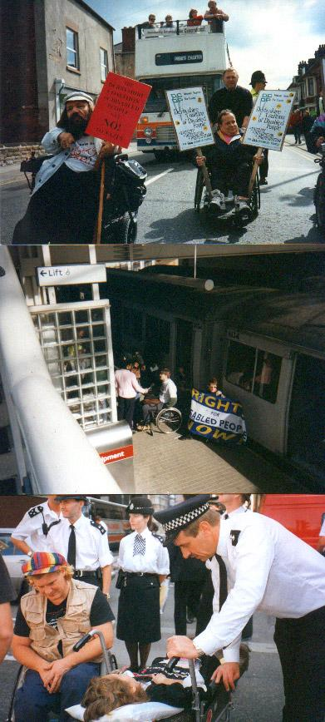
Johnny was there when DAN was born in 1992. It all began informally two years earlier when over 1,000 activists turned out to protest a British television telethon that was the same in its patronizing, degrading tone as the Jerry Lewis telethon in the U.S. After an even bigger protest the next year, the telethon was discontinued.
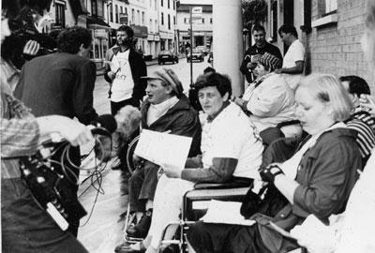 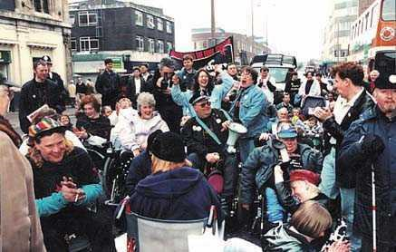
Building on the momentum, DAN was formed and the first national campaign was called WE WILL RIDE, with the goal of making all public transit accessible. Johnny and company chained themselves to trains, blocked buses and tried to crawl into Parliament. They had a barbecue in the lobby of a government office building, burning a government document calling for limited transit access instead of charcoal. "I guess we really are fire risks!" Johnny says.
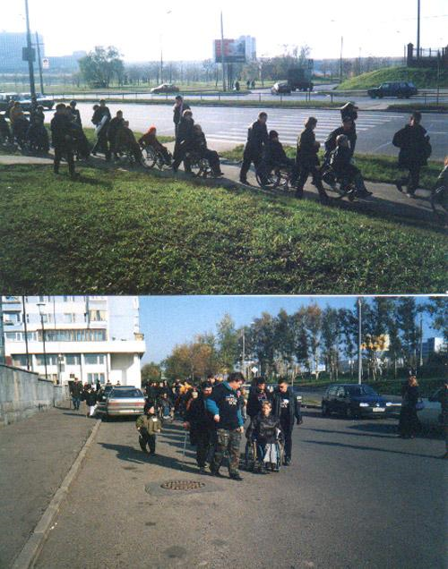
Leading an Action in Moscow Whooee scarry!
But the tactics worked. "DAN was getting very high profile publicity and disabled people's issues were moving off the charity pages and into the political pages." Though there is no formal legislation requiring it, Johnny says, all new public buses are now wheelchair accessible. He's also sure all the publicity DAN generated led to the passage of the Disability Discrimination Act in 1995, which he describes as "a watered down version of the ADA."
Learning strategies
So DAN launched its current national campaign in 1999. The goal of FREE OUR PEOPLE is to create enough services and supports so every person with a disability can live in their community rather than an institution. Johnny says, " We'd been campaigning for five years already on WE WILL RIDE and we'd learned many lessons. Not least we learned that even with direct action, it can take time. Also, you have to break up your demands into achievable chunks and finally, unfortunately, you have to go to meetings. WE WILL RIDE was a simple campaign with simple demands that everyone could understand. FREE OUR PEOPLE was going to prove more complex and I believe that without WE WILL RIDE, we wouldn't have been experienced or sophisticated enough to even attempt FREE OUR PEOPLE."
The new campaign has had some successes too with the creation of some new independent living centers and support systems. But Johnny knows it will be a long haul. "FREE OUR PEOPLE will not be won in a single action or in a year. We are still learning how to be most effective and how to use direct action strategically. We won accessible transport and we will free our people."
Johnny's main partner in organizing DAN and in life these days is his second wife, Cassie James. Cassie was once a leader of the Philadelphia ADAPT chapter. Johnny and Cassie are such hard core ADAPTers that they even got married at the conclusion of the 1999 national ADAPT action in Columbus, Ohio. In July 2000, Cassie gave birth to Johnny's second daughter. They named her Danielle. Johnny says the pun in the name is intended-- DAN-YELL

The Ballard of Roy and Julie http://www.microsoft.com/windows/windowsmedia/images/Download_88x31_static.gif

Johnny Crescendo
Roy and Julie were lovers they met at a special school
The didn’t tell nobody because the knew that true love was against the rules

Once a week on Friday night they’d meet around Roy’s apartment flat
They’d talk about settling down getting married and this and that

Julie’s mother was glad that her daughter she had finally found a friend
She’d never considered where Julies devotion might end

Roy had never had a father or mother to call his own
They’d sold him into slavery at birth and put him in a nursing home

Julies father called Julie his constant little girl
And he loved her like any father loved a five year old in the world

But Julie was seventeen and Julie had thoughts of her own
She was scared of people dying and her being left all on her own

Back in the apartment Roy and Julie began to explore
Feelings about each other that they had never felt for anyone before

Two virgins on the couch two virgins on the floor
No one had ever told them but they found out what they were looking for

Julie was packing boxes in the center when Roy burst through the door
She thought something was coming cos Roy hadn’t done anything like this before

Roy was kinda shy as he offered Julie a golden ring
And that’s how he proposed and that’s why Julies heart began to sing

At first they kept it secret from Roy’s social worker and Julies mum and dad
But Julie held a secret in her heart that made her feel bad

The doctor she had gone to had told her that a child was on its way
And as a doctor he felt responsible to tell her mother right away

So Julie told Roy about his child and a smile lit up his face
After all the things he’d been denied yeah he could finally take his place

They talked about housing about the child and about the child
When Julie finally left Roy couldn’t sleep his thoughts were running wild

Next evening excited Roy went around to Julies home
He’d put on his best clothes and brought Champaign to celebrate with Julie’s folks

At the door he met her father who was brimming with patronizing rage
He told him to go away and to never show his face round there again

He argued on the doorstep and Julies mother finally called the police
He was angry he was arrested but Roy finally left in peace

And three months later Julie had a boy and named him john
And Roy never knew even when his son was born

When john was six months old the family adopted john away
And Julies’ never seen her little boy since that fateful day

Roy’s social worker fought for him and now he sees his son once a month
Julie went into a psychiatric hospital referred there y her mum

In the psychiatric meeting where the white coats are supposed to strip you bare
Julie fixates on the window and she twists and pulls her tattered hair

The white coats sip their coffee each one wondering what the hell they are doing there
And finally they just leave her in her room rocking in her chair

Julie gently rocks and hums the only words shell ever say
She remembers the love and the bonds that were so cruelly taken away

She’ll hum these words forever until her dying day
They’ve taken my baby away

Music Johnny Crescendo
Guitars Andy Morgan
Vocals and harmonica Johnny Crescendo

THE BALLAD OF ROY AND JULIE
I knew Roy but I never met Julie (both names have been changed). It’s a true story, faithfully told. It took an age to write because I wanted to tell it in plain language so that the very people experiencing the same thing as Roy and Julie would understand and relate to the song. Andy and I agreed that we should just state the bare facts musically and emotionally because the tale tells it all. This is especially for all women with learning difficulties who’s children have been taken away from them because the people without learning difficulties can’t come up with a way to support real families! It’s a helpless song and is supposed to make you think surely something could have been done? At the moment it isn’t…..organize!

Pride
Pride is somewhere in your soul
Pride is the peace within that finally makes you whole
Celebrate your difference with pride
Pride in yourself is bound to set you free
Pride in who you are just a person like me
Pride and self respect and gentle dignity
No one can take away your pride
Pride can make you angry. Pride can make you strong
Pride's the key that unlocks the doors to the rooms where we belong
Pride is our destiny and where we all come from
Turn around embrace your pride
Proud angry and strong
Proud angry and strong
Proud angry and strong
Pride can make you equal without your liberty
Pride can give it's freedom to a prisoner like me
Pride is always with you wherever you may be
Once won you'll never lose your pride
Pride is a rocky road that's straight and doesn't bend
Prides a path you follow Pride's your closest friend
Pride's the source inside your heart from which you can draw strength
Begin all your 'journeyings' with pride
Pride's the bond between us. Pride's the bridge we burn
Pride's the victory the battle, from which we shall return
Pride's the spark of fire within, the crucible the germ
The seed of our power is our pride
Proud angry and strong
Proud angry and strong…

Where d'ya get that leg?'
An autobiographical poem of Johhny’s
“Where d'ya get that leg?'
Are you alright on the stairs? and
'Where d'ya get that leg?'
Why do you walk silly?
Oh by the way -Where d'ya get that leg?'
I don't mean to be personal son, but
Where d'ya get that leg?'
As it affected half your bum and
Where d'ya get that leg?'
Does it hurt, is it painful, do you wear it in bed?
What about Douglas Barder eh and
'Where d'ya get that leg?'
He's very brave if you ask me and
Where's he get that leg?
Does he take it off to pee and
Where's he get that leg?
I knew a man without a brain,
He spent his life in bed,
His parents were under quite a strain, and
Where's he get that leg?
Is it captain still, rather you than me,
Still you're okay I suppose,
Take a look at me.
No thanks.
I've got problems with my zips,
I've squeezed them 'til they're red,
We all have our cross to bear
And Where d'ya get that leg?'
I got it with some petrol -it was going free
I got it 'cos I never wipe my willie when I wee
I got it by accident, I got it through bad luck
Cos it was run over by a Yorkie bar
disguised as a truck.
I got it for Christmas, for mi' birthday,
for Halloween,
Which leg are you talking about,
I don't know what you mean.
It's a down payment on a robot,
It's a jock strap for mi' dick.
Where do you get your questions from
Because they really make me ***** sick!”

One song more than any other became the anthem of the Disability Movement

Choices and Rights Johnny Crescendo (AKA Alan Holdsworth)
I want Choices and Rights
Choices and Rights
Choices and Rights in my life

I don’t want your charity
Or for you to be paid to care for me
I want Choices and Rights in my life

I don’t want to be in your care
Or to be put some place out there
I want Choices and Rights in my life

Choices and Rights,
That’s where we’ve got to fight
Choices and Rights In my life

I don’t want no benefit
But dignity from where we sit
I want Choices and Rights in our lives
I don’t want you to speak for me
Just listen and then you’ll see
We want Choices and Rights in our lives

Choices and Rights,
That’s where we’ve got to fight
Choices and Rights in our lives

I don’t want your sorry
I don’t need your fear
We want Choices and Rights in our lives

I don’t want your guilt trip
I don’t need your tears
I want Choices and Rights in our lives.

We don’t need your special schools
We gotta get out and teach them fools
We’ve got Choices and Rights in our lives

I’m not going to stick out my hand
Together we’re going to make a stand
We got Choices and Rights in our lives

Choices and Rights,
That’s where we’ve got to fight for
Choices and Rights In my life

We don’t need your charity
Or holidays by the sea
We want Choices and Rights in our lives

And white coats are burned on fires
As our strength grows higher
We want Choices and Rights in our lives

One flew east, one flew west
One flew over the cuckoos nest
For Choices and Rights in our lives

Choices and Rights,
That’s where we’ve got to fight
Choices and Rights In our life x2

Activities

- Watch Johnny singing Choices and Rights and/or Pride why do you think these songs became so important to the Disabled Peoples Movement?
- Watch extracts from Desperate Dan . This shows the Direct Action Network taking direct action to establish the right to get on public transport. At the time in the mid 1990’s there was no legislation or end date to make Public Transport accessible for disabled people in the UK. Make a list of the arguments in favour of DAN and its direct Action and Against Peaceful Direct Action.
- Have a class debate around the issue of direct action. You might want to link to other civil disobedience in struggles for rights against slavery, for women rights, the right to vote, trade union rights, civil rights for Black People in Southern USA, Congress’s struggle in India to get the British Empire to leave.
- Read about Johnny’s life and identify what in his life experience made him a composer /musician and civil rights campaigner?
- Read the poem ‘Where d’ya get that leg from’ . What is it about?
- Write your own poem/or compose your own song about the prejudice disabled people experience.
- Read the Ballad of Roy and Julie. Analyse the attitudes expressed by Julie’s parents and the professionals. Do you think these views are justified or a breach of these young peoples human ‘Right to Life, Liberty and the Pursuit of Human Happiness’( American Constitution).

