Richard III and the portrayal of disability
Shakespeare's Richard III drew heavily on a distorted history that sought to demonise Richard, the last Plantagenet King, and justify the usurping of the throne by Henry Tudor (Henry VII). Accounts of Richard III written in his lifetime don't describe any impairment. Portraits painted from life were altered later to give him a 'humpback'. Thomas Moore invented a 'limp' and 'withered arm'. Someone supposedly capable of such monstrous crimes was made into a monster.
Some modern historians believe that Richard was a just king, but too trusting of those around him, who had shown themselves capable of betraying him. These historians don't hold Richard responsible for the string of deaths that led to his accession to the throne, and think it's unlikely that he had the Princes in the Tower murdered. This myth became the basis of Tudor propaganda, written some years after Richard's death.
This was one of 10 history plays and 8 of them concentrate on the Wars of the Roses between Lancaster and York.
- Richard II
- Henry IV pt 1
- Henry IV pt 2
- Henry V
- Henry VI, pt 1
- Henry VI, pt 2
- Henry VI, pt 3 Richard appears in this play as Gloucester
- Richard III and this play is about his rise to power.
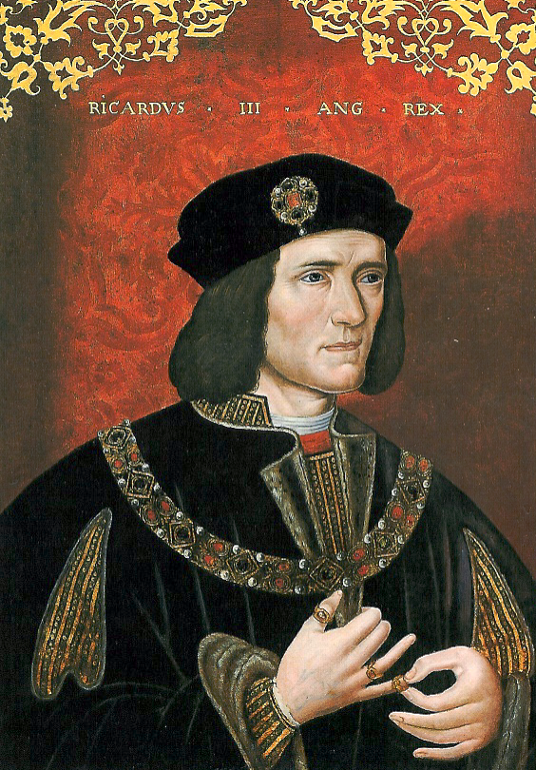
Shakespeare took great liberties with the historical facts; characters were added, time was compressed and the plays have a strong moral message.
painted from life, which hangs in the National Portrait Gallery, an ordinary looking king.
The curators of the museum X-rayed this picture and found the slight raising of the right shoulder was painted in some 60 years after the original to fit the Tudor propaganda that was developing around Richard III.
Richard III, began as a flesh and blood person but over time, thanks to Shakespeare and a highly efficient Tudor propaganda campaign, turned into a fictional character who resembled only in the vaguest way the human being who was the source of the myth. http://www.r3.org/bosworth/stockton.html
Let us think for a moment about the villainy attributed to Richard by his most famous detractor, William Shakespeare. Shakespeare describes Richard in the following way: unfinished, a lump of foul deformity, inhuman, unnatural, misshapen, with a dissembling nature, a rooting hog, the slander of his mother's womb, the loathed issue of his father's loins, a yonder dog, a hell hound, a carnal cur, a bloody dog, scum, and vomit.
Shakespeare says Richard incited the king against his conspiratorial brother Clarence, even though historians agree Richard was Clarence's chief defender; Shakespeare says Richard killed his own wife so he could make a more propitious marriage, although historians say he was distraught at her death; and Shakespeare says Richard had his trusting nephews killed to clear his way to power, although there is no firm evidence of this and much of the evidence that exists (all of it circumstantial) points to his enemies and accusers as the possible culprits.
Is there then anything we can praise? Indeed, there is. To historians, the evil deeds of Richard swirl in controversy and dispute but his achievements are not in doubt.
- He was a good and honest administrator.
- He strengthened the jury system.
- He created a system of bail for those accused of crime.
- He strengthened the fiscal system.
- He strengthened freedom of religion.
- He pardoned his enemies and tried to reunite his wounded country.
- He was personally devout, honorable, and courageous.
- And he was devoted to his family and grievously mourned the wife and child who preceded him in death

In Henry Part III Richards appearance and character resulting have already been introduced to the audience
Why, love foreswore me in my mother’s womb,
And for I should not deal in her soft laws,
She did corrupt frail nature with some bribe
To shrink mine arm up like a withered shrub,
To make an envious mountain on my back
Where sits deformity to mock my body,
To shaper my legs of an unequal size,
To disproportion me in every part
Like to a chaos, or an unlicked bear-whelp
That carries no impression like the dam.
From Henry VI, Part III lines 155-162

So why is the image of Richard III so strong as a monstrous, unscrupulous, murderer who will stop at nothing to gain his ambition of the Crown of England? One answer is that Shakespeare wrote a magnificent play with powerful lines drawing on superstition and stereotype to cement his evil disabled character into place.

Act I Scene I GLOUCESTER
“Now is the winter of our discontent
Made glorious summer by this sun of York;
And all the clouds that lour'd upon our house
In the deep bosom of the ocean buried.
Now are our brows bound with victorious wreaths;
Our bruised arms hung up for monuments;
Our stern alarums changed to merry meetings,
Our dreadful marches to delightful measures.
Grim-visaged war hath smooth'd his wrinkled front;
And now, instead of mounting barded steeds
To fright the souls of fearful adversaries,
He capers nimbly in a lady's chamber
To the lascivious pleasing of a lute.
But I, that am not shaped for sportive tricks,
Nor made to court an amorous looking-glass;
I, that am rudely stamp'd, and want love's majesty
To strut before a wanton ambling nymph;
I, that am curtail'd of this fair proportion,
Cheated of feature by dissembling nature,
Deformed, unfinish'd, sent before my time
Into this breathing world, scarce half made up,
And that so lamely and unfashionable
That dogs bark at me as I halt by them;
Why, I, in this weak piping time of peace,
Have no delight to pass away the time,
Unless to spy my shadow in the sun
And descant on mine own deformity:
And therefore, since I cannot prove a lover,
To entertain these fair well-spoken days,
I am determined to prove a villain
And hate the idle pleasures of these days….”
Though this first speech sets the tone of the play, Richard, in flirting with the Lady Anne, whose husband he had recently killed does not believe the view of himself he has portrayed because he believes he can ‘have her’ However her responses to him reinforce the view he has painted of himself with her calling him the devil, a dissembler and a misshapen toad.
There are at least two stereotypes of disability in play here. The first the disabled person as evil or sinister and this has many manifestations from Captains Hook and Ahab to the villains in James Bond. The second the disabled person with a chip on his shoulder wishing to get back at the world for the ‘sad trick of fate’ played upon them. However, as the play develops there is another stereotype which is the disabled person as overcoming adversity and achieving against the odds. The ‘super crip’
“I’ll make my heaven to dream upon the crown,
And whiles I live t’account this world but hell
Until my misshaped trunk that bears this head
Be round impaled with a glorious crown.”
Henry VI, Part 3 3.2.168-171

Here it Francis Bacon’s essay on Deformity will give a insight into this other view of disabled people as driven leaders. There is an old German proverb ‘The cripple always leads the dance.’ This view will also be one that Shakespeare was familiar with.

Of Deformity From Manuscripts 1612, 1625 by Francis Bacon
“Deformed persons are commonly even with nature: for as nature hath done ill by them, so do they by nature, being for the most part (as the Scripture saith) void of natural affection; and so they have their revenge of nature. Certainly there is a consent between the body and the mind, and where nature erreth in the one, she ventureth in the other: Ubi peccat in uno, periclitatur in altero. But because there is in man an election touching the frame of his mind, and a necessity in the frame of his body, the stars of natural inclination are sometimes obscured by the sun of discipline and virtue. Therefore it is good to consider of deformity, not as a sign, which is more deceivable, but as a cause, which seldom faileth of the effect. Whosoever hath anything fixed in his person that doth induce contempt, hath also a perpetual spur in himself to rescue and deliver himself from scorn. Therefore all deformed persons are extreme bold — first, as in their own defence, as being exposed to scorn, but in process of time, by a general habit. Also, it stirreth in them industry, and especially of this kind, to watch and observe the weakness of others, that they may have somewhat to repay. Again, in their superiors, it quencheth jealousy towards them, as persons that they think they may at pleasure despise; and it layeth their competitors and emulators asleep, as never believing they should be in possibility of advancement, till they see them in possession. So that upon the matter, in a great wit deformity is an advantage to rising. Kings in ancient times (and at this present in some countries) were wont to put great trust in eunuchs, because they that are envious towards all are more obnoxious and officious towards one. But yet their trust towards them hath rather been as to good spies and good whisperers than good magistrates and officers. And much like is the reason of deformed persons. Still the ground is, they will, if they be of spirit, seek to free themselves from scorn, which must be either by virtue or malice. And therefore let it not be marvelled if sometimes they prove excellent persons; as was Agesilaus , Zanger the son of Solyman, Aesop, Gasca, President of Peru; and Socrates may go likewise amongst them, with others.”
Richard uses his impairment to gain pity and to put the blame on witchcraft.
“I pray you all, tell me what they deserve
That do conspire my death with devilish plots
Of damned witchcraft, and that have prevailed
Upon my body with their hellish charms?
[Richard continues…]
Then be your eyes the witness of their evil
[he shows his arm]
Look how I am bewitched! Behold mine arm
Is like a blasted sapling withered up;”
Richard III 3.4.60-64 and 68-70
In act 2, scene 1 of Shakespeare’s The Tragedy of King Richard III, Richard of Gloucester brings the unhappy news that his brother, Clarence, next in line for the throne, has been executed. The King replies “Is Clarence dead? The order was reversed” (2.1.89). To which Richard responds “But he poor man, by your first order died; and that with winged mercury did bear.; Some tardy cripple bore the countermand” (1.2.90-92) The aside about the tardy cripple is an inside joke with the audience. Richard in fact is the “tardy cripple” to which he refers and we know it. Shakespeare created a monster and one that very clearly is viewed and views himself as monstrous because of his outward physical deficiencies and deformities.
Thompson, having examined the many portrayals of Richard III points out that it is only since the 1980’s that the emphasis has been on portraying the hump back, withered arm or lame leg.
[“Some Tardy Cripple”:The Evolution of Disability in Performances of William Shakespeare’s Richard III, Gregory J. Thompson,Research in the Humanities Colloquia – RSU ,February 27, 2009
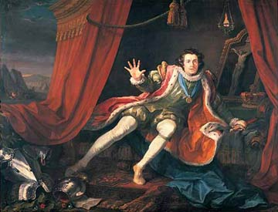
“David Garrick as Richard III” 1741
Painting by William Hogarth
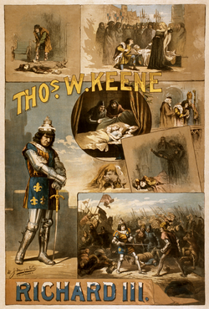

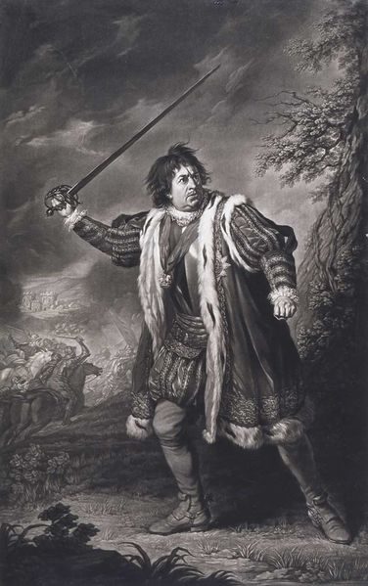

1810 Etching
Throughout the 18th and 19th centuries Richard was
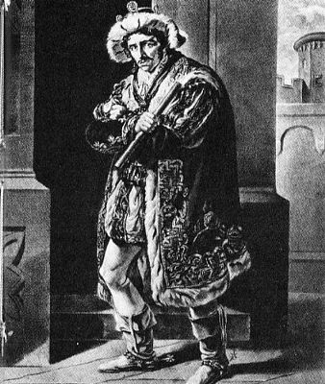
not portrayed as disabled.

Edmund Kean as Richard III 1789-1833
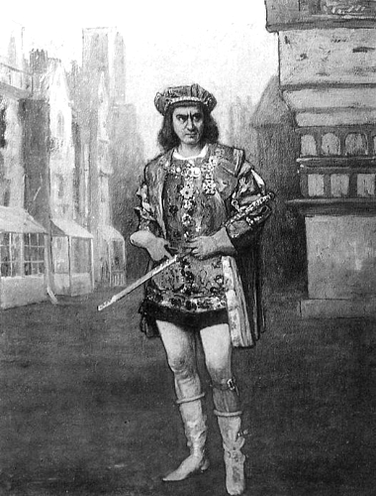
Edwin Booth1833-1893 Richard Mansfield
1857-1907(Richard III c.1889)
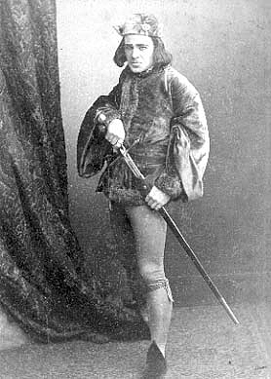

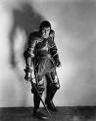
John Barrymore 1929. The body is twisted with a sinister shadow.

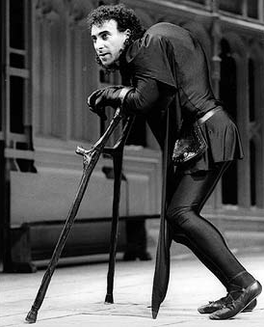
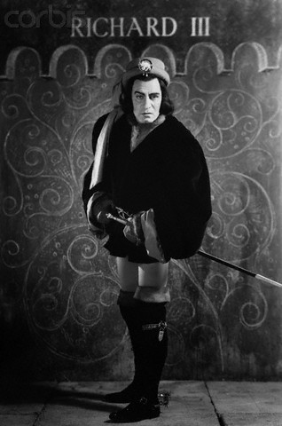
Lawrence Olivier in 1930’s played on stage and 1947 with a slight limp.

1984 RSC Production
Anthony Sher came up with the idea after spending nearly a year on crutches while recovering from a ruptured Achilles tendon. 1984 Able bodied actor Antony Sher but emphasis on physical.
Sher studied the movements of those with scoliosis but he also studied the behavior of psychopathic killers.”
“His Richard, in other words, may act out of personal pain an rejection, but he’s still a psychopath.”

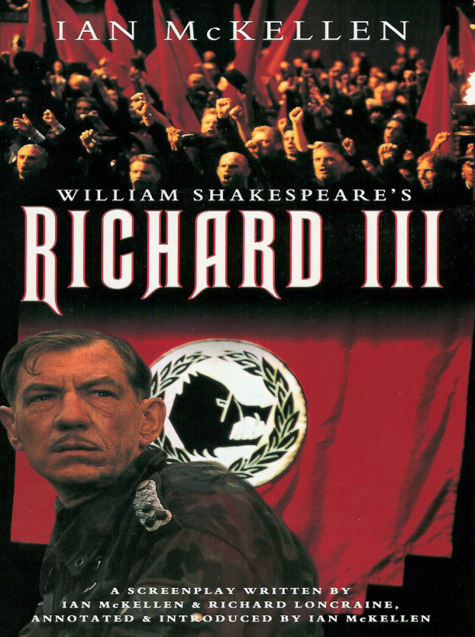
1995 Film with Ian McKellan who again portrayed Richard as disabled.
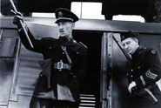

Henry Holden, a disabled actor, 2007
Spoon Theatre, New York, NY

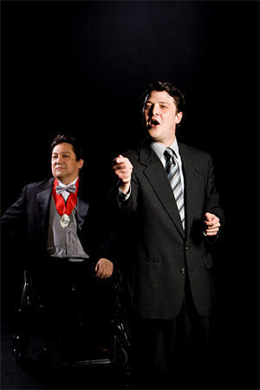

Rene Moreno, 2008, Kitchen Dog Theatre Dallas, Texas
Richard is in a Wheel Chair

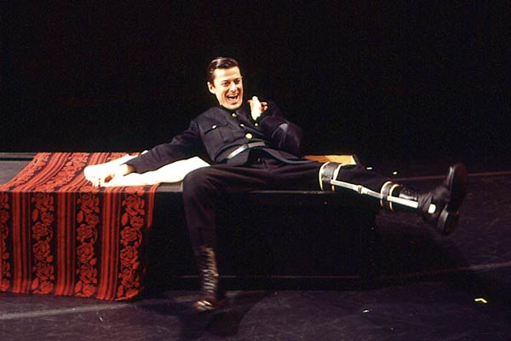

Gammon

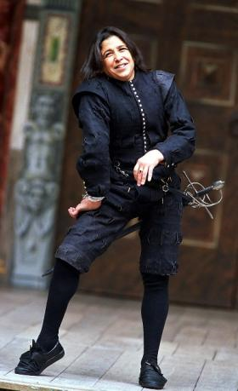
Katherine Hunter 2003 the Globe. Katherine is a disabled actor and one of the first women to play Richard.

In recent productions – really since the 1984 RSC production, the perception of Richard changes (by the audience). Richard has become more aware of his physicality and he is responding to people with that knowledge. The actors are emphasizing a Richard, who feels left out of the circle because of his disabilities. In review of the 2008 Kitchen Dog Theatre production in Dallas, it was written “A hurt resentful Richard isn’t necessarily more sympathetic – just more human.”
Perhaps this coincides with a period where disability rights and equality have come up the political agenda with the Disability Rights Movement starting in the mid 1960’s leading to the Americans with Disabilities Act ( 1991 ) disability Discrimination Act (1995) in the UK and in 2006 the United Nations Convention on the Rights of People with Disabilities .
Sources
http://www.william-shakespeare.info/script-text-richard-iii.htm
http://www.youtube.com/watch?v=thz2EUizC9Q Olivier Act 1 Scene 1
http://www.infobritain.co.uk/Richard_The_Third.htm Castle
http://en.wikipedia.org/wiki/Richard_III_(play)
http://www.richardiii.net/
www.rsu.edu/academics/comm/theatre/.../richard3/r3TardyCripple.ppt
Richard the Third by Michael Hicks (Tempus, 2001) (ISBN 0-7524-2302-9
Good King Richard Jeremy Potter

