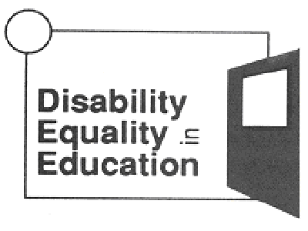
Equal Education for All

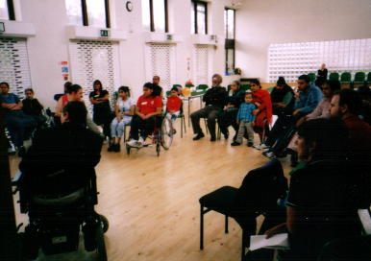

PACE (Physical Activities Club in Ealing)

Disability Equality in Education
Black and Ethnic Minority Project

by Krishna Birdy

Contents

Introduction

Conferences

Feedback from Parents

Guest Speakers

Sapna’s Story

The Young People’s Group

Disability Rights & SEN Fair

Reinforcing Relationships – Outreach

Development of PACE

Establishing PACE

PACE-ing Forward

Recommendations

Introduction

Our Community

Our community is like a dead pond
Which does not want to move
There should be a constructive approach

Otherwise we are going to stagnate

By Jagdeep Rait

This project began three years ago with two primary aims. Firstly to introduce Black and Minority Ethnic (BME) parents of disabled children to the benefits of inclusive education by ensuring they were aware of the new legislation (Special Educational Needs and Disability Act 2001) affecting their disabled children’s educational rights. Secondly, to give BME young disabled people an opportunity to discuss issues relating to their disability and culture and encourage them to become disability equality trainers, presenting positive role models for their disabled peers.

Work began in two of the most culturally diverse communities in London, Brent and Ealing. The numbers of BME disabled children attending special schools were investigated. We sought to establish whether a proportionately high number of BME disabled children attended special schools as opposed to mainstream schools compared to White disabled children. Although a breakdown in the ethnicity of those disabled children attending special schools was available, the Boroughs in question did not have the figures relating to ethnicity of disabled children attending mainstream schools.

Local disability organisations were contacted and initial meetings with BME parents of disabled children revealed that, to a large extent, their cultural beliefs influenced their attitudes towards disability and therefore expectations from their disabled child. This was further reinforced by the lack of understanding of their needs by support agencies and professionals outside of their culture. Similarly, BME young disabled people felt misunderstood and frustrated because of the attitudinal and physical barriers they faced not just from those within their own community but also from society as a whole. The lack of accessibility to services led many BME families of disabled children feeling isolated from their own communities and society. In the course of this project, in order to deliver its aims, it became increasingly essential to ‘work in the community’ on a one-to-one basis with families and young disabled people. This ‘outreach’ work established key areas where families of disabled children were receiving the minimum support they were entitled to. This was putting a lot of undue pressure and stress not only on the family but also on the disabled child/young person leading them to feeling responsible for any ‘upset’ in the family. The one-to-one work with families and young disabled people has been a very important aspect of this project with parents needing to know they could discuss certain issues in the privacy of their own homes. They also felt more confident talking to someone from a similar background, someone who they felt understood their culture, language and could also empathise with them as a parent of a disabled child.

In supporting young disabled people, it was important to listen to what they wanted and to find a solution to their concerns. This has been quite a difficult road to travel as many of the disabled young people felt their views on how they wanted to live their lives were not taken seriously by those around them. They felt that because of the level of personal care and support they needed due to the nature of their disability, they were often treated like ‘babies’. Many of the young disabled people had not received the appropriate support throughout their school life and had left fulltime education without any skills, qualifications or training.

The workshops and seminars that were delivered for BME parents and their disabled children provided insights in to the issues regarding these families that needed tackling. The feedback from parents and young disabled people has been very positive from a slow change in attitude towards disablement to feeling empowered to promoting a positive change in life. This is seen in the emergence of PACE (Physical Activities Club in Ealing) where parents and their disabled children have an opportunity to make some positive changes in their lives.

This project has been funded by Comic Relief.
(Also by DEE and donations).

Conferences

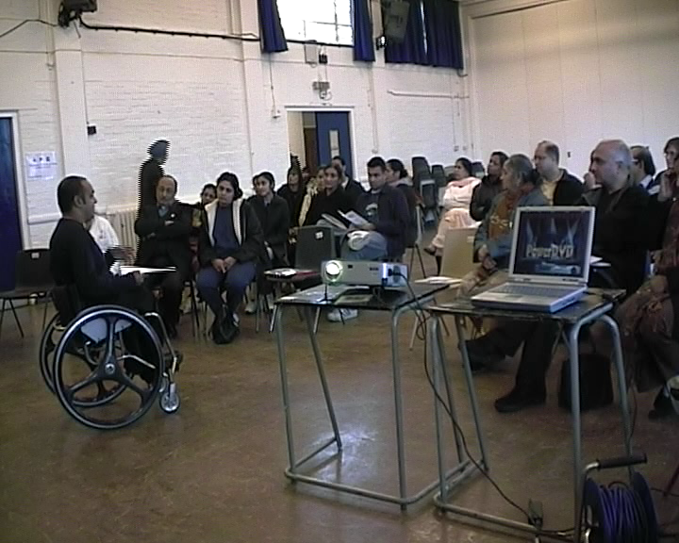

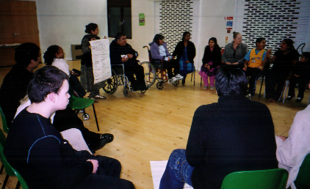

The following groups offering services to families of disabled children within Brent, Ealing and the neighbouring boroughs were contacted:

- Association of Muslims with Disabilities (AMD),
- Contact-a-Family (in Southall and Ealing),
- Ashiana,
- Brent Association of Disabled People (BADP),
- Parent Partnership Groups (in Brent and Ealing),
- Brent Carers Group,
- Ethnic Minority Access Participation Project,
- Mencap,
- Connexions
- Home-school liaison officers from some of the local special schools,
- Adults with Learning Difficulties Team
- Clubs organised by Ealing Mencap and Connexions for young people with learning and physical disabilities

In addition, local Gurudwaras, Mandirs (temples) and Mosques were also approached to ensure families of disabled children who may not be registered with the above organisations or even know of their existence would have the opportunity of attending the conferences. Posters describing the purpose and content of the conferences were displayed on their notice boards. Announcements regarding meetings were also promoted via the local radio station, Desi. It was important to reach all sections of the community, particularly those where language may be a barrier to accessing services.
Some of the groups held regular meetings for parents to discuss particular concerns and obtain relevant information. Attendance at these meetings was generally by mothers and in some cases they brought their children with them. Many of the mothers found these sessions useful not just for the sharing of information but also it gave them an opportunity to socialise with other people who they felt understood their situation. Through listening to the stories that parents talked about and the concerns they had, three predominant areas emerged:

Education.

A very high proportion of disabled children attended special schools. Parents had been led to believe that “special schooling is the only option” for their disabled child. Many parents said they were made to feel the professionals involved with their child knew their child better than they the parents and therefore did not feel confident questioning decisions made by these ‘professionals.’ In all cases, parents were not aware of support agencies such as parent partnership groups that existed for their benefit. Although almost all the young disabled people had a Statement of Special Educational Needs, parents were not aware of what is was or what it entailed. Many parents had not been to the Annual Review meetings and were not aware they could submit a report on what their disabled child could do at home. This would lead to a misrepresentation of what the child could fully do as in some cases of children with severe communication difficulties, parents had developed their own form of communication with their children but this was not being utilised to its full potential in the school environment. A few parents disclosed that they had actually not been informed about their child’s Annual Review until after it had taken place.

Post School Opportunities

“My son went to a special school. When he was 16, he could not do any exams because we were told he cannot read or write. We don’t know what he was doing at school for all those years. Recently, he has been getting very depressed and just stays in his room. Most days he will stay in bed. On the odd occasion if some friends offer to take him to the cinema, he gets excited and looks forward to this outing all day. He’ll make an effort with his appearance. But on the other days, he gets very down and stays in his room. What we need is some one to help take him out a bit more”.
Mother of 21 year old boy with cerebral palsy.

Parents of disabled children and disabled young people were not happy with the transitional options being offered at sixteen plus. Many parents showed surprise when informed that their disabled child may be able to attend college or further education. They believed that their disabled child would be staying at home after fulltime education, accepting this as the normal course of events for a disabled person. This belief was further reinforced by parents of older disabled children who had experienced difficulties in securing any form of training, appropriate further education or suitable employment for their disabled child. Another important issue was the lack of any appropriate social activities for young disabled people, (particularly for those over the age of eighteen years). They wanted to participate in activities that were fully accessible and they enjoyed because “staying at home is boring and you don’t get a social life”.

Independence

Many families were experiencing problems with getting direct payments and support towards independent living despite systems being in place to deliver these. Feelings of frustration and anger were prevalent amongst the young disabled adults towards social services because felt they had enough to deal with, emotionally and physically, without having to contend with the inadequacies of those in ‘authority’. Although young disabled adults accepted they had physical limitations, they felt very positive about achieving a certain level of independence if given the appropriate support.

Inappropriate support also consisted of, in the case of disabled young men, the provision of female personal assistants. They preferred male personal assistants and felt embarrassed having their personal care being delivered by female staff.
Some of the disabled young adults (mainly the males) showed subtle signs of anxiety over finding partners, believing that no-one would want to spend their life with a disabled person except perhaps another disabled person. Some families felt that the only way their disabled sons could find a suitable partner would be from their country of origin.
Many parents of disabled children and disabled young adults were not aware of their entitlements to improve their quality of life. For example, many families did not know of the Taxi-card scheme operating in London and were prevented from attending certain events because they were frustrated with the unreliability of existing transport options. One twenty-year old young person with cerebral palsy was still using the same wheelchair that he had been issued with at the age of ten. He was not only too big for it but it was decrepit. There had been a breakdown in communication between the parents and the support agencies basically because the parents were not competent in English.

Perceptions of Disability

The underlying vein running through the three main areas of concern amongst the predominantly Asian families of disabled children were the cultural beliefs of their communities towards disablement. Parents of disabled children felt that they did not only have to contend with the lack of understanding from professionals regarding the needs of their disabled children but also the negative attitudes towards disability from their own communities. The belief in the Asian community that disability occurs within the family because of misdeeds in previous lives either by the parents or the disabled child themselves is strongly reinforced by those who do not have a disabled person in their family. The presence of any form of disability is accepted as ‘punishment’ for these misdeeds. Whereas most parents felt that they could only seek emotional support from other parents of disabled children because of their understanding of their situation, the disabled young people felt annoyance with their parents and with the community. They believed generally that they were disabled due to circumstances beyond their control and accepted their condition or impairment as being part of them.

Parents emotionally described how they felt other people perceived their disabled children, seeing them as objects of pity needing “sympathy, help” and “love”. Parents felt their disabled children should be “encouraged to fight for life” because that was all they had to look forward to, a big struggle. Some of the comments made by parents as to how other people perceived their disabled children were,

“lack confidence; alter behaviour; can’t communicate well; need patience; fear of disabled; can’t think for themselves; can’t do anything for themselves; having special transport; having special schooling; non-sexual feelings; well catered for; behaviour problems; different”

Parents felt so undervalued and lacked confidence in questioning those working with their disabled children.

Bearing in mind the issues raised by parents of disabled children and young disabled people, the conferences were structured in a way that would not only increase awareness of inclusive education and provide information regarding current new legislation affecting a disabled child’s right to a mainstream education but also provide a forum for parents and disabled young people to discuss issues directly affecting them, particularly concerning disablement. The concerns raised were not just present in Black and Asian families but right across the board, in all nationalities.

Programme Structure

The conferences and workshops had to be structured in such a way that would
- inform parents of their rights regarding not only their children’s education but also the duties service providers and businesses have under the Disability Discrimination Act 1995, empowering them to challenge those that discriminate.
- attempt to change attitudes towards disability from the medical model of thinking towards social model thinking.
- hear the voices of young Asian disabled people and empower them to move forward in achieving what they want for their future.
- give opportunities for young Asian disabled people to express themselves through creative writing, drama and music workshops.
- accommodate any siblings of young disabled people attending the workshops. Siblings often found themselves in the role of carers, in some cases, as much as the parents.

Above all, the workshops should be informative, empowering, inspiring and fun for parents of disabled children and young disabled people. It was going to be important for families to feel they were getting something constructive and positive from the workshops because they “were fed up of attending meetings where we are asked what our needs are but then no-one does anything about it”. A pack consisting of useful information had been put together for parents to take home. It included a parent-friendly summary of SEN Statements and duties under the Special Educational Needs and Disability Act 2001, quotes from the Code of Practice regarding working in partnership with parents and a list of organisations providing information and advice on special educational needs. It also included the Disability Rights Commission Guide for Parents re Part 4 of the Disability Discrimination Act 1995.

Feedback from Parents

Although parents wanted what every parent dreams of for their child,

“happiness; opportunities to fulfil their potential; social integration; independence; to have the necessary support; have interests; knowledge of their mother tongue; to have choices; to have a good home; live in the community; to have a job; to be in a relationship; to communicate better; star player in a football team”

they felt the future looked bleak for their child and “did not know what would happen to them when we are not around.” Parents felt that their dreams were achievable to a certain extent if their disabled children were to receive the appropriate support. On the whole, parents of disabled children felt very isolated, unable to approach any professional body for support. Their main sources of information regarding rights, benefits etc, were other parents. There was a general air of despondency by parents towards the educational system, many feeling

“special schooling is the only option; no support; progression (educational) is not at an appropriate rate; more educational support required; limited choices; inconsistency between boroughs; lack of communication; there is a hidden agenda by professionals; parents are supported by other parents”

Although many of the children had a Statement of Special Educational Needs, their parents did not know what it entailed and its purpose. One parent asked “is that what they call the IEP (Individual Educational Plan)?” Parents did not know the complaints procedure if they were not happy with their child’s Statement or who to approach and what to do if they wanted their child restatemented. Also, they did not know what the different sections of the Statement meant or the type of provision their child may be entitled to to enable access to the curriculum. The general view of parents was,

“You don’t like to keep asking questions, even when you are not quite happy with the way they (teachers, professionals) are working with your child, you think it must be something you don’t understand. So you don’t ask questions.”

Parents were eager to learn about their rights and the decision-making processes they should be involved in. However, they felt the only way they could move on was to enrol the support of
- “family members” who had an emotional attachment for their disabled family member.
- “the law” because it was felt to be the only way rights to an appropriate education for their disabled child might be enforced.
- “teachers with the right qualifications” because parents did not feel confident that teachers always understood how needs of their disabled children could best be met. More training in this area was required along with a willingness for them to work in partnership with parents.
- “parent organisations” especially as parents of older disabled children were able to empathise and offer support to those parents of disabled children who had recently entered the educational system and were encountering problems.
- “media coverage” firstly to promote disabled Asian role models in whichever area and secondly to increase awareness of support groups for parents.

As a first step to making some positive changes in their lives, parents of disabled children felt “small organisations should come together” as there was strength in unity as opposed to individuals fighting alone. Towards the end of the workshops, parents were gaining confidence and beginning to assert that “disability does not mean disadvantage” and that having an impairment does not mean their disabled child should be denied access to LIFE. They were determined to “look more into the law and rights” to increase awareness of their rights and ensure the appropriate provision was being made available allowing their disabled child access to mainstream life. Some parents said they needed to “revisit Statement” because they could not remember the last time they had seen their child’s Statement of SEN. All parents wanted “diversity” to be accepted as normal.

Some of the comments made by parents regarding the workshops are,

“More seminars discussing all aspects relating to disability or special needs.”

“Opened our minds into information which we were not aware”

“very informative day”

Guest Speakers

The workshops have been attended by a number of ‘guest speakers’ to talk about their personal experiences and to provide information on services their organisations offer.

Sapna has severe cerebral palsy, a speech impairment and is a wheelchair user. She spoke about her experiences of special schooling, where teachers thought she “did not understand anything” and then of her experiences of mainstream school where she learned to read and write at the age of 17. She was placed in mainstream solely due to the closure of her special school. She went on to do a degree and recently finished a Masters, something she feels very strongly she would not have been able to achieve had she continued at a special school. Mainstream school also gave her an opportunity to build a network of friends, something that had been impossible to do in her special school. Sapna’s talk was “very moving and inspirational” for parents to hear. It clearly required a great deal of effort on her part to talk about the issues she felt so passionate and angry about, “it’s not that special schools have low expectations of you, it’s that they have no expectations of you.”

Sapna’s father, spoke of his experiences as a parent of a disabled child, the isolation and lack of support he encountered and how soul breaking it can be when you have no-one to turn to for just a little bit of support and to feel no-one understands your situation and just basic human rights have to be fought for through the courts. Preethi, another parent of a disabled child, spoke of her struggle to get a mainstream place for her daughter and the problems she was encountering even after the placement had taken place. This was reinforcing the idea that inclusion is not just about placing disabled children in mainstream schools but how the school must then ensure the child has an opportunity to play an active part as in the school community.

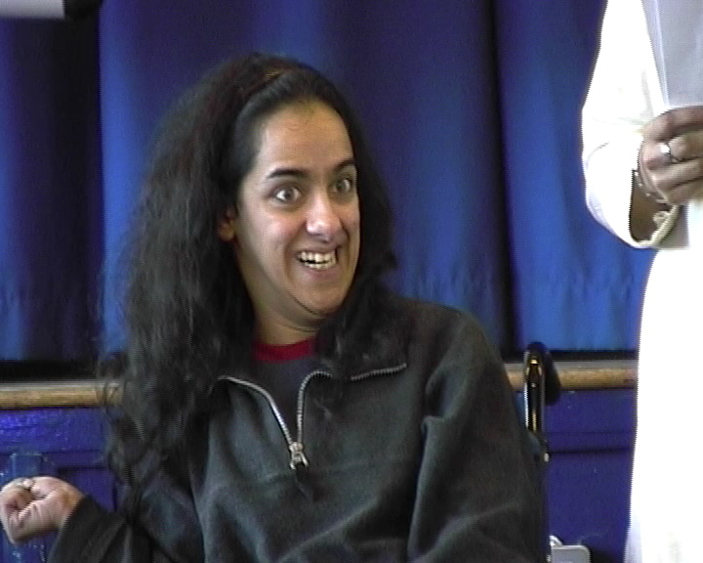

Sapna’s Story

“Having completed a Degree and a Masters, I am now in the process of establishing myself as an independent documentary filmmaker. I am looking back to the time I went to a special school and consider the influence and effects it had on me then and now.

Martindale, what did it mean to be there for me? Why did I have so many problems there? How did it affect me mentally, physically and emotionally? I was in an unnatural environment, I think due to my speech impairment, I could not prove myself to the teachers. The teachers did not realise that I could actually speak and my brain was in full working order, I only had a physical disability. Even though I would communicate with my family and friends, the teachers would not encourage me to communicate verbally with them and I was too young to realise that I had a greater potential than they realised. I communicated by pointing to Makaton signs on a board. I soon found this a frustrating way to communicate since there was a limit to how much I could say. However I learnt to read the words underneath and did not bother to learn the large number of the signs. The teachers never found out that I had the ability to read and write which I only managed to learn extensively at the age of seventeen, when I was placed in a mainstream school once Martindale had been closed down due to a lack of students.

I felt constantly un-stimulated. I was aware of my lack of knowledge and education while I knew that I had average intelligence however I did not get any opportunity to prove it. I was more aware of my environment and mental deterioration than the teachers, psychologists or the other children were. I was never given a sign of recognition that I was capable of mainstream education, I therefore assumed that the people around me did not understand my full potential and did not even understand that I had my aspirations of going to university.

I did not have a normal teenage environment since most of the children around me had learning difficulties and behaviour problems and this affected me since I did not learn the emotional and psychological differences between men and women. Even when Martindale closed down and I was put in to a normal environment I had problems communicating and being around men. It wasn’t until recently that I realised that. However, I am now trying to understand this situation in order to overcome it and have a normal and healthy relationship.

The main problems started after I was about 12. Some of the brighter children who were physically more able than I was and who did not have speech impairment left Martindale. Gradually there was a decline in the level of education. The school was left with fewer children who had severe mental and physical disabilities. After this time, there were fewer subjects and the work became a lot less challenging. This is when I noticed that I was deteriorating mentally and it was extremely frightening even though it was a gradual something violent towards them. There was something about them, which made me angry inside. In a way it felt like I could read their minds and knew how they felt towards me. By now most of the reasonably good or better teachers had left and the school was employing those with little or no experience with disability and with very low expectations of those who they supposedly taught.

At that time, my understanding of my environment was that the staff did not believe that any of the children were capable of doing much with their lives, it was like our minds were in suspension for twelve years. The staff were not cruel or unkind to any other pupil or me but there was something in their attitude that really made me want to run away or to do something violent towards them.

Perhaps I was in Martindale simply because I did not have any other place to go. Perhaps I was there because it was easy to organise, maybe it was the most cost effective way of looking after me. I do not know the real reason that I remained there. All I know, that it was wrong and down right insane of the school and the local authority to keep me in such an institution.
I did not know anything of the outside world or the opportunities that I could have if I was in the normal society. I didn’t know how to hold a conversation and lacked other social skills, I knew that people who went to University have a good education and could go on to do what they wanted in their lives and this is where I wanted to end up.

Martindale had two different departments, the main block was for children under sixteen and a department in another building called extended course, which was like a further education development for young adults over sixteen. When I was fourteen, I began communicating with a teacher in this department and managed to explain some of my situation, I also told him that the work was too easy and I was getting frustrated at the other department. I carried on this dialogue over a few months after which it was agreed that I would be moved to extended course. I was delighted at the thought of being challenged and thought it was impressive to be in a class with people who where two years or more older than I was. I was disappointed in the first hour since the work was even more ridiculously simple than the main school for younger people. However, I was most disappointed by the fact that the people in my class were two years older than me but did not have a clue about what was going on.

There was a new computer teacher, Alistair, who was working in school, I found him interesting to be with. As time went by I spent a lot more time with him as he taught me how to draw on the computer and I used this to handle my frustration. Alistair was different and he taught me new and interesting things. I soon learnt to type on my own using a switch and special software.

Soon the news came that the school was closing down. I remember that on the last day of school, most of the pupils were crying and seemed very upset. I must have been one of the few who didn’t feel any emotion on the day. Even though I was extremely unsure about my future I knew that this was a great day to be free.

I then met someone in October of the same year as Martindale closed down and he became a major influence in my life. Carlos Sibbick was assigned to be my personal assistant in the mainstream school that I joined. I began my education in Feltham Community School, a mainstream school. Carlos was the first person I met who did not make any assumptions about my disability. In the summer holidays prior to joining, I was told by the co-ordinator of the school that they had appointed a young man to be my personal assistant.

I had an incredible amount of support from my teachers at Feltham Community School. It seemed as if the more enthusiasm I expressed, the greater they wanted to support me. They were very much aware of my lack of knowledge. However, after a few months I managed to cope with the work and understand what was being taught.

After a while learning became easier and my confidence grew. I knew that he (Carlos) was the only person that was giving me the education that I wanted, I felt human and alive. Martindale was very much in the past where I hoped it would remain. While sitting with
situation, but there was no comparison. After many years of being oppressed and being perceived as someone who did not have a future, here was someone who had the time to give me the education that I had always wanted and the demeanor that I longed for.

Two years later as the news reported that the annual GCSE results were out, I could not wait to receive them in the post, as the anticipation was overwhelming. So I asked my Dad to phone the school and to my delight but not surprised I had passed all my subjects. Apparently according to Mrs Hampstead who was the special needs co-ordinator of the borough of Hounslow, I was the first person with a disability to obtain GCSEs in the borough. This made me sad since I thought about all the other children who may have not been so lucky, why was I the first one. This was another turning point in my life since I was aware that many people had a close watch on me, the girl with special needs whom they thought would remain uneducated and without a future.

As I am writing this, I have managed to complete an MA, a BA and a GNVQ advanced. I tracked Carlos down some years later and invited him over; I wanted to show him what I had achieved and most of all my GCSE certificates. I can still remember the expression on his face when he saw them. It was an expression of pure joy and most of all I managed to thank him for his effort. It only takes a single person to have a little time and persistence to put one on the right path in order for them to realize their ambitions and goals. Carlos certainly did that for me.

Once I was performing well in Feltham, I could not have got better support even if I had looked for it. I think my parents needed to realise that mainstream education was possible and the best thing for me, once they were confident and comfortable with this new idea, they supported me right through my education. My brother has always gone out of his way to support and guide me through my education. He is five years older than I am and being a young man with his own ambitions, aspirations and problems. However this has not prevented him from giving the support and advice that I need. I have worked so damn hard to get where I am today and I have had to overcome so many barriers that sometimes seemed unnecessary, I will not forget the support and love of my family.

Some people may think that I have done something extraordinary and great. This is a foolish thought since society has an obvious problem with disable people, as it is them who define my limitations. I do not need any bench mark to see what I have done, it is only when I am satisfied that I know that I have completed what I have set out to do and I am only half way there.“

“The purpose of education is to bring out the best in you”
Mohandas Karamchand Gandhi

The Young People’s Group

My Disability

Disability is like a shadow
It follows me everywhere
It is like having a brain without a body
It is like a bug which hangs to me all the time
I wish it leaves me for good
I do not hate my life
I hate the position I am in
It shadows me everywhere
I can see the world but I cannot live the way I want to
I am in a massive Black Hole and I am never going to get out of it

It is like I have been cursed
It feels as if I got a blockage in my head
I wish I could kill it
I wish I was an animal
I would be free.
By Jagdeep Rait

During the meetings with parents and their children, where the young disabled person had been asked a question directly, in almost all cases, the parent tended to answer for their child. It was vital that these young people be given a voice, a chance to express themselves and for them to feel that whatever they said would not be disclosed without their permission. The group were asked to talk about their dreams for their future and how they felt they could achieve these. They were asked to express their feeling through pictures and posters. To ensure that these young people felt comfortable and at ease, the following ground rules were put in place

- Facilitators should not be seen as teachers. Everyone in the group would be of equal importance.
- To allow as much time as required for a young person to express their dream, any barriers to their dream and how these barriers could be broken.
- To encourage discussion around any particular topic raised by a young person.
- Confidentiality. Individual posters would not be shown if this was their request. Instead, a group poster would be created for presentation to parents at the end of the conference.

As the workshops were open events, it was not possible to know precisely the range of abilities of the young people attending. Differentiating the workshops ensured all participants had an opportunity to access the contents.
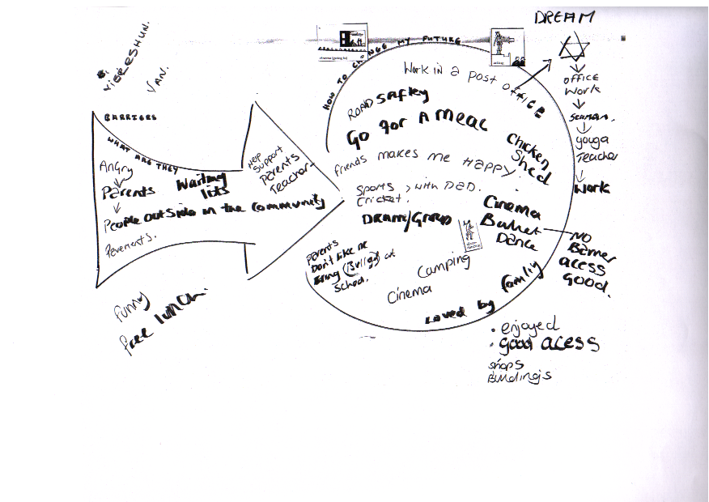

Feedback from the Young People’s Group

Building Dreams

All the young people had very positive aspirations of their future whilst recognising there were certain barriers they would have to overcome to realise their dreams. Some of the dreams the young people had were,

“be a yoga teacher, be a seaman, go to a ballet, go camping, go for a meal”

However, they felt that certain barriers prevented them from achieving their dreams. They felt “angry” because of the situations they found themselves in, stating it was not just “people outside in the community” who hindered their progress with their negative attitudes towards disability but sometimes their “parents” too failed to support them in the right way. A disabled teenager being bullied at school was kept at home by her parents because rather than address the situation with school, it was easier to keep her at home. The young person wanted to go to school and felt resentful about having to stay at home. The parents did not feel confident in challenging those in authority and considered the ‘fault’ must lie with their child. The young people recognised that “help to support parents and teachers” was necessary so that they in turn could offer the appropriate support to young disabled people and help them achieve their goals. Physical accessibility was another major concern, preventing opportunities for independence. They felt their parents would probably let them go out more with their friends if there was “good access to shops and buildings.”

The Dream of one boy (with learning difficulties) was to work in an office and/or work for a computer company. His Barrier was the way he sometimes felt “loving, malicious, puzzled, sad/unhappy.” He said he could change his future by “get exam results from college”. This student clearly wanted to get a job in an office and recognised he had to get some type of qualification as he had written “get qualification, good exam result” a number of times on his poster and then crossed these words out. Did he feel he would never achieve this because some of the feelings that overcame him?

One parent had not wanted to bring her son to the meeting because “he will not be able to stay in one place and needs a lot of supervision” At the end of the session, this mum was beaming with delight when her son volunteered to stand up and present his “dream” to the parents group. Although one of the barriers to his dream was that he felt “my parents don’t like me,” something he said would make him very happy would be “to play cricket with his dad”. At the end of the workshop, his father came over to me and said, “I never thought of playing cricket with my son.” This was something he intended on rectifying.

Parents were very moved and overwhelmed by the posters their children had made, some of whom were for the first time expressing their dreams for their future.

Creative Writing

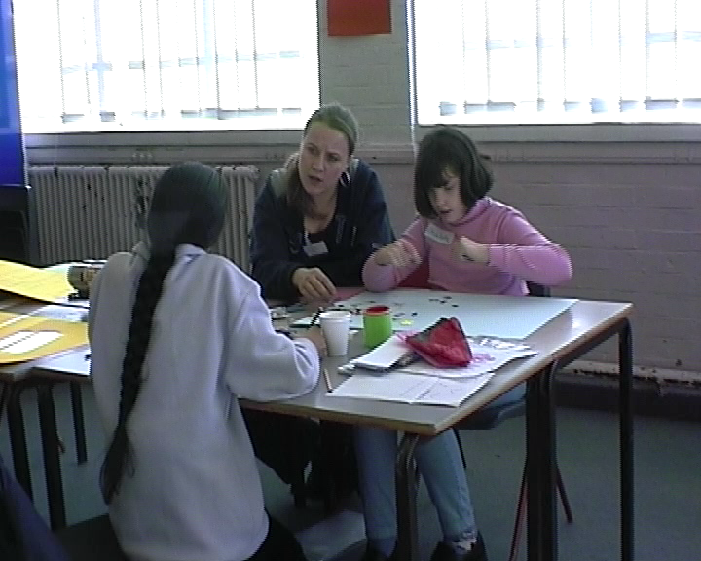
This workshop gave the opportunity for exploring stories and poems through the young persons own examples. The support workers did an excellent job of differentiating the tasks, enabling all its participants to produce a piece of work.

In one case with a child with communication difficulties, a word box was constructed through brainstorming ideas. A few drafts later, this child was able to produce a final version of her poem as follows:

The Light in the Night!

The stars twinkle,
And the moons shine,
The houses are quiet,
It is now night.

I would like to go to sleep,
I feel very tired,
I can see the silky fur of the cat
Throughout the window night.

The light in my room,
Keeps shining on my eyes,
My eyes start to close
And I start to fall,
fall,
fall asleep.
Another group member who communicated through yes/no responses was able to build an outline for a story. Although it was very tiring for him (he fell asleep for a short period whilst writing), he was very excited and became very animated during his writing session. He was so enthusiastic and put together a brilliant story. There was not enough time to think of a title but the story is well worth reading:

“Once upon a time there was a big lion that roared loudly because he was the King of the Jungle. Everybody was scared of the King Lion, the rabbits were scared, the snails were scared, the deer were scared and so the lion was the Boss! The other animals began to get very fed up because the lion would eat all the food – which sometimes was them! One day a visitor came to the jungle, he was slippery, slimy, he was sneaky, he was sly, he was super sly, he was called Ssssssunil. When slippery Sunil the slimy snake saw the animals looking so fed up, he asked them what was wrong, and the rabbits said, “We are fed up of being eaten,”
and slippery sly Sunil thought to himself – but he didn’t say, “That’s a shame because I’m hungry too!”
Sunil the snake had a good idea and he said to all the other animals, “don’t worry, don’t fear, slippery Sunil is here to save you.”
“How are you going to save us?” the animals replied.
“I am going to have a competition with the Lion.”
“But you will get eaten,” they cried.
“We will see,” he sniggered.
All the animals gathered around the big rock where the king sat and laughed when he heard the snake was going to challenge him.
“Snakes can’t run,” he laughed to himself, “snakes can’t roar, this is going to be fun. I haven’t had snake for a long time.”
The snake was calm, he slid slyly up to the lion and said,
“This is a yawning competition Your Majesty because as you know lions are famous for their yawns.”
“Mmmm,” said the Lion, “very interesting.”
But to get the best yawn as you know, you have to close your eyes. There was a hush all around. The bear counted 1…..2…..3 and the yawning began. The Lion opened his mouth and let out a huge yawn but the snake opened his mouth wider, slid stealthily up, stretched his jaw wider, sprung forwards and swallowed him up. The lion was gone forever.”

Graeae and Drumming

Disability Rights and Special Educational Needs Fair

The support being provided to individual families with disabled children introduced a whole range of diverse issues that needed to be addressed. A section of the community was not accessing the services they were entitled to for their disabled children. This was not just common to Asian parents of disabled children but right across the board. By bringing a cross range of organisations and service providers under one roof, it would allow parents and young disabled people to have access to and be aware of the service providers operating for their benefit. This would also give the service providers an opportunity to build community links and network.

- Southall and West London College
- Ealing Centre for Independent Living
- Ealing Crossroads
- Children with Disabilities Team (Ealing)
- Ealing Mencap
- Southall Contact-a-Family
- Intuition PPIMS (formerly Ealing Parent Partnership)
- Connexions Disability Project
- EMAPP (Ethnic Minority Access Participation Project)
- Learning Curve
- Participation Unit - Youth Forum
- Alternative Therapy for Carers and Disabled People.
- Adults with Learning Disabilities Network.

Alka Triparthi represented the Ethnic Minority Access Participation Project (EMAPP), operating in Ealing and Hounslow. She talked about how this project had established a focus group for parents and carers of disabled children from the ethnic minority community. They met once a month to discuss issues and problems relevant to their communities. EMAPP also advises parents on services available to them. Parents and carers have an opportunity to meet each other and exchange information. Consultation forums are also organised where professionals are invited to open channels of communication between communities.

Sian Vasey, Director of the Ealing Centre for Independent Living (ECIL) explained how the Centre is building up a strong disability organisation in Ealing providing support and information to the local community. There is space in their centre for people to meet and discuss issues around disability that affect them. Recently, an advice session with a lawyer once a week to deal with any legal queries had been started. They also offer advice and information on The Special Educational Needs and Disability Act 2001 and The Disability Discrimination Act 1995. ECIL have also recently received funding to get people with learning disabilities onto the direct payments system.

Beverley Ireland-Symonds from Southall and West London College explained how this college was meeting its duties under the Special Educational Needs and Disability Act 2001. This local college was making provision for students who have severe learning disabilities and physical disabilities and will provide specialist equipment and one to one support to assist with learning where required. However, they were unable to currently make the necessary provision for those students requiring a high level of personal care or who needed medication to be administered.

Andrea Priest represented Ealing Crossroads, an organisation which provides respite care breaks for parents and or carers looking after disabled children between the ages of 11 to 18 years old. Crossroads offer respite in the home environment although they will also take children on any activities or outings that they participate in. There is also an after school club for eleven to sixteen year olds held at the Ealing Centre for Independent Living.

The Disability Rights and SEN Fair presented parents with an overview of the Disability Discrimination Act 1995, in an accessible format. In particular, it reinforced for them how disability is defined, who is covered by this Act, duties of service providers, access to goods and services and the new duties all education providers must have in place to ensure that disabled students, current and prospective, are not being discriminated against. Parents complained about the standard of services offered and how they felt that if they did follow the complaints procedures, often the buck was just passed from one department to another. Parents voiced that they “have enough on their plates. Why do they have to go through extra hassles? Why don’t people just do their jobs?”

Many of the organisations attending the Fair felt that because of time constraints on a daily basis, they did not always get an opportunity to converse with each other and this was an ideal way for them to network and update themselves as to what was happening in the community. Some of their comments regarding the Fair were,

“the Special Educational Needs Fair on 7/02/04 was a very useful networking tool for us and potential users and carers alike – thank you.”

“Well done on a successful event”

“The day highlighted the importance of projects such as EMAPP, as there is a growing interest from our ethnic minority communities about the services available to them.”

Insert Table of Disability Rights and SEN Fair 7.2.04

Reinforcing Relationships - Outreach

To increase confidence and trust of the parents and their disabled children it was necessary to provide one-to-one support. The caseload of families requiring support gradually increased over the course of the project. Some of the families that have been supported are

- Tania, a 19 year old with Downs Syndrome, attended a mainstream local college. Her parents had received complaints from the college stating that Tania would often walk out of lessons and was not performing well in her academic work. Initial meetings with the parents and Tania revealed that actually she wanted to find employment but was feeling pressurised by her parents to attend college. They felt Tania had no option but to keep doing some course at college because it would be very difficult to find an employer that would offer a job to someone with learning difficulties. A meeting with the college was set up and it was discovered that Tania had not only been enrolled onto an inappropriate course but she was not receiving the level of support she required to access the course. It was therefore not surprising that she tended to walk out of lessons, mainly because the work was not at the correct level for her. After a further meeting with the college and in consultation with Tania, she was enrolled on a course that would enhance her numeracy and literacy skills. Tania would also be given an opportunity to work in the college library for one afternoon a week, thus providing her with valuable work experience. The parents were also satisfied with this arrangement because she was going to be in a “supported environment”.
- The parents of a sixteen year old girl with cerebral palsy were extremely worried when they were told that their disabled daughter would have to attend a residential special college when she left school. Her parents were reluctant to question the advice being offered because they thought this “was the only option for her” after school. The young disabled person was thrilled to learn that she had an option of attending the local mainstream college and her parents were thrilled that their daughter would be coming home every evening after a day at college.
- The parents of Gurpreet, a nine year old boy with cerebral palsy asked for his Statement to be explained to them. After analysing his Statement, it was apparent that the only reason for his attendance at the local special school was because of its physical accessibility. The parents then asked their Local Education Authority to amend his Statement. A transfer to an accessible mainstream school, with the appropriate support, was arranged. After spending a year in mainstream school, Gurpreet has recently taken entrance exams to a Grammar school and passed with flying colours.
- A twenty year old with cerebral palsy was using the same wheelchair he had been given at the age of ten. He could take a few steps using a walking frame by ‘hanging’ over it. He was attending college and did not like using his wheelchair because it was falling to bits. However, using his walking frame was very tiring and limiting as to how much he could do because he could only cover a short distance with it. His parents had been in touch with social services but support had not been forthcoming. Within three weeks of making the initial contact with social services on their behalf, organising an appointment and attending the wheelchair clinic with them, this young person left the clinic with a new wheelchair. He was delighted and could not wait to return to college to show off his “new set of wheels”.
- Anupam, cerebral palsy and hemiplegia re extra time at university to complete assignments
- Vina, cp re Statementing and provision of therapies
- Ali, hearing impairment, employment prospects and marriage
- Vijay, learning difficulties, parents needed support in interpreting college report and attending parents’ evening at college
- Chaney, cerebral palsy, inappropriate provision at mainstream due to lack of understanding and good practice led to parents wanting their child to attend residential special school. Referred for legal advice.
- Marcus, learning difficulties, residential issues, connexions service failing family.
- Jagdeep, cerebral palsy, taxicard, employment, PACE training, Graeae Missing Piece Course

Development of PACE (Physical Activities Club in Ealing)

The support provided to the culturally diverse families and their disabled children on a one to one basis highlighted a gap in service provision that was not being addressed by the appropriate service providers. Parents of disabled children and young disabled people themselves felt that the established organisations existing to support them were not fully meeting their needs on an emotional, cultural and social level.

Provision for further education exists for disabled students after they leave school but it appears to be so only up to the age of about twenty-one years old. After this, it seems the only options available are to either attend a day centre, where the existing clientele are much older or to stay at home. Parents and their disabled children were very disillusioned as to what the future held for them. They felt there was a lack of appropriate education, skills, training, activities and employment opportunities.

A growing demand where young disabled people and their families could meet on a regular basis to socialise, actively participate in activities such as sports, games, dancing, arts and crafts and also discuss issues affecting them as being members of a culturally diverse community and their disablement was beginning to emerge through the workshops and consultative sessions. In order to develop any form of ‘club’ for primarily young disabled people between the ages of 13 and 25 years old and their friends and siblings, it would be important to develop the foundation on which this club would be based. The ethos of the club would be based on equal opportunity, full participation and personal development. This would be delivered by ensuring
- The venue to be fully accessible and have the appropriate facilities with costs being kept to a minimum.
- Activities the club undertakes should be initiated by its members and facilitated by the organisers.
- All members, (that is participants and support staff) should be equally valued and have a very clear understanding of the ethos of the club.
- All sports and games activities should be fully accessible to all members ensuring opportunities for equal participation.
- Workshops such as dancing, arts and crafts should take into account the needs of all our members.
- Opportunities for members to discuss issues affecting aspects of their lives and to feel supported and empowered.
- All members felt they were learning skills and gaining experience at a personal level.
- Parents felt confident their disabled child was in a safe environment.
- Opportunities for parents to network and exchange information
- All members had fun.

Developing Links

An accessible venue was sought and located in the form of Havelock Community Centre in the heart of Southall. A meeting was arranged with Julie Brooker from The Acton Housing Association where the project and its benefits to the local community were discussed. The Housing Association generously offered to provide the community hall free of charge for an initial period of six months to establish the clubs’ feasibility.

The London Sport Forum for Disabled People (LSF) was approached for advice on inclusive sports and games. The support provided by Tim Wood, the Sports Development Officer, has consisted of an introduction to a range of inclusive sports such as table top games (for example, Poly Bat, Table Cricket), a para-olympic sport called Boccia, Slalom(?), adapted Volleyball, Hockey and Basketball. In addition, he has shown us how to deliver warm-ups ensuring all members participate at a level adapted to their physical ability.

Jayesh Solanki a qualified choreographer and a parent of a disabled child, offered his services for free. He manages the inclusive dance workshop for the group at the end of the session. Jayesh also provides the music.

A small number of volunteers (older siblings of some of the young disabled children) offered their services to provide support in the running of the sessions.

We also registered our club with Ealing Community Transport so that our group would have accessible transport to any trips we may go on.

Our first session was promoted through the contacts established over the last two years of this project including local schools, colleges and local disability organisations mentioned earlier in this report. We also promoted our club through Desi Radio, the local Punjabi radio station to ensure all sections of the community were aware of its existence.

Response to the First Session

The number of people who attended our first session was as follows:

Young disabled people 12

Non-disabled young people 5

Total young people registered 17

Parents 18

Support staff 4

Facilitators 4

Total adults 26

Total people attending 43

Ethnicity of total young people registered:

White - British 2

Black – British 1
Indian 14

Total 17

From the twelve young disabled people, two were on the autistic spectrum, seven were wheelchair users (of which four have cerebral palsy, one has muscular dystrophy, one has a hearing impairment, one has very severe cerebral palsy and uses augmentative communication), two have muscular dystrophy and one has ‘moderate learning difficulties’.

Step Four – Establishing PACE

All members need to register by completing a form disclosing personal and health details. Membership is for young disabled people between the ages of twelve and twenty-five years old and their friends and siblings. Parents and carers are asked to remain on the premises because we do not currently have enough qualified support workers to assist our members. However, we do not generally allow parents to work or support their disabled child during the sessions, all support is provided from within the group.

Initially we were known as the Saturday Club. Members were asked to suggest possible names for our club that would reflect its ethos. This was our first ‘brainstorming’ activity as a group. This activity revealed that because of the complex communication methods some of our members had, it meant that we needed to present topics for discussion or problems requiring solutions in one session and ask for their feedback in the following session. This allowed those members who require time to communicate their ideas/suggestions an opportunity to be included in the group placing an equal value on all ideas/suggestions presented. Members voted for PACE (Physical Activities Club in Ealing) and this was adopted as our official name.

The next step was to develop a set of rules for PACE. Members decided on the following Code of Conduct:

PACE

Code of Conduct

- Respect one another as individuals.
- Behave towards others as you would want to be treated.
- Don’t swear or fight.
- Don’t tease or make fun of other people.
- Play and share fairly.
- Don’t be greedy.
- Be polite.
- Help each other.
- Be positive.
10. Always tell a responsible adult if someone is harassing you.

Activities

Our sessions normally begin with a warm up followed by two sports activities. After a short break for light refreshments, members have an option of either continuing with sports or attending the dance workshop. Art workshops are arranged when either requested or for a particular purpose. We regularly have ‘brainstorming’ activities to discover ways of improving our club.

Sports – PACE members enjoy a variety of adapted sports and games. Tim from the London Sports Forum for Disabled People and Lauren from Active Ealing have introduced us to the following sports:
- Boccia (pronounced ‘botcher’) is similar to Bowls. It is a para-olympic sport and may be played either on an individual level or in teams. It is one of the popular games with our members.
- Adapted Basketball is also very popular, we have a range of balls which members can use to practise shots and their ‘sending and receiving’ skills.
- New Age Curling.
- A range of table-top games such as Poly Bat and Table Cricket.
- Adapted Hockey.
- Adapted Volleyball
- Skittles

Members thoroughly enjoy the active participation in the games,
“it’s so good to be actually taking part in a game and not just watching other people playing it” PACE member

Overall, parents feel,
“movement is great for our kids, it really helps them with their coordination”

Dance – These sessions are great for expelling inhibitions and are enjoyed not only PACE members but also their parents and carers.

Art – To date, PACE members have made Christmas cards, Valentine cards and currently, we are making posters defining our Club.

Forum – Michelle Daley from Disability Equality in Education delivered a workshop on empowerment. PACE members discussed how they could take more control of their lives and be involved in the decision making process. They felt they needed,

“people to listen to me, powered wheelchairs, Braille, sign language, automatic doors, clear areas, adaptations, ramps, lifts, Disability Living Allowance”

Training – During the year two PACE members, Sunil and Jagdeep, attended a course for Adapting Physical Activities which was organised by Youth-sport in Feltham. The course involved some theory work around the meaning of disability and the use of positive and negative language and its effects. This was followed by practical examples of how people with a range of disabilities could be included in sports sessions, how games could be adapted and how to manage certain situations involving hidden disabilities. Both members did extremely well on the course and the knowledge they gained has been an asset for PACE.

Trips – two trips have been organised this year. The first was to a Summer Sailing Event organised by Sailability at Surrey Docks Sports Centre in London. This was a fantastic opportunity for members to try their hand at sailing. All the boats were adapted and there were qualified instructors present to provide an insight into sailing techniques for disabled people. Members thoroughly enjoyed the day, their enthusiasm radiated brilliantly because they were actually participating in sailing and not just watching from a distance.

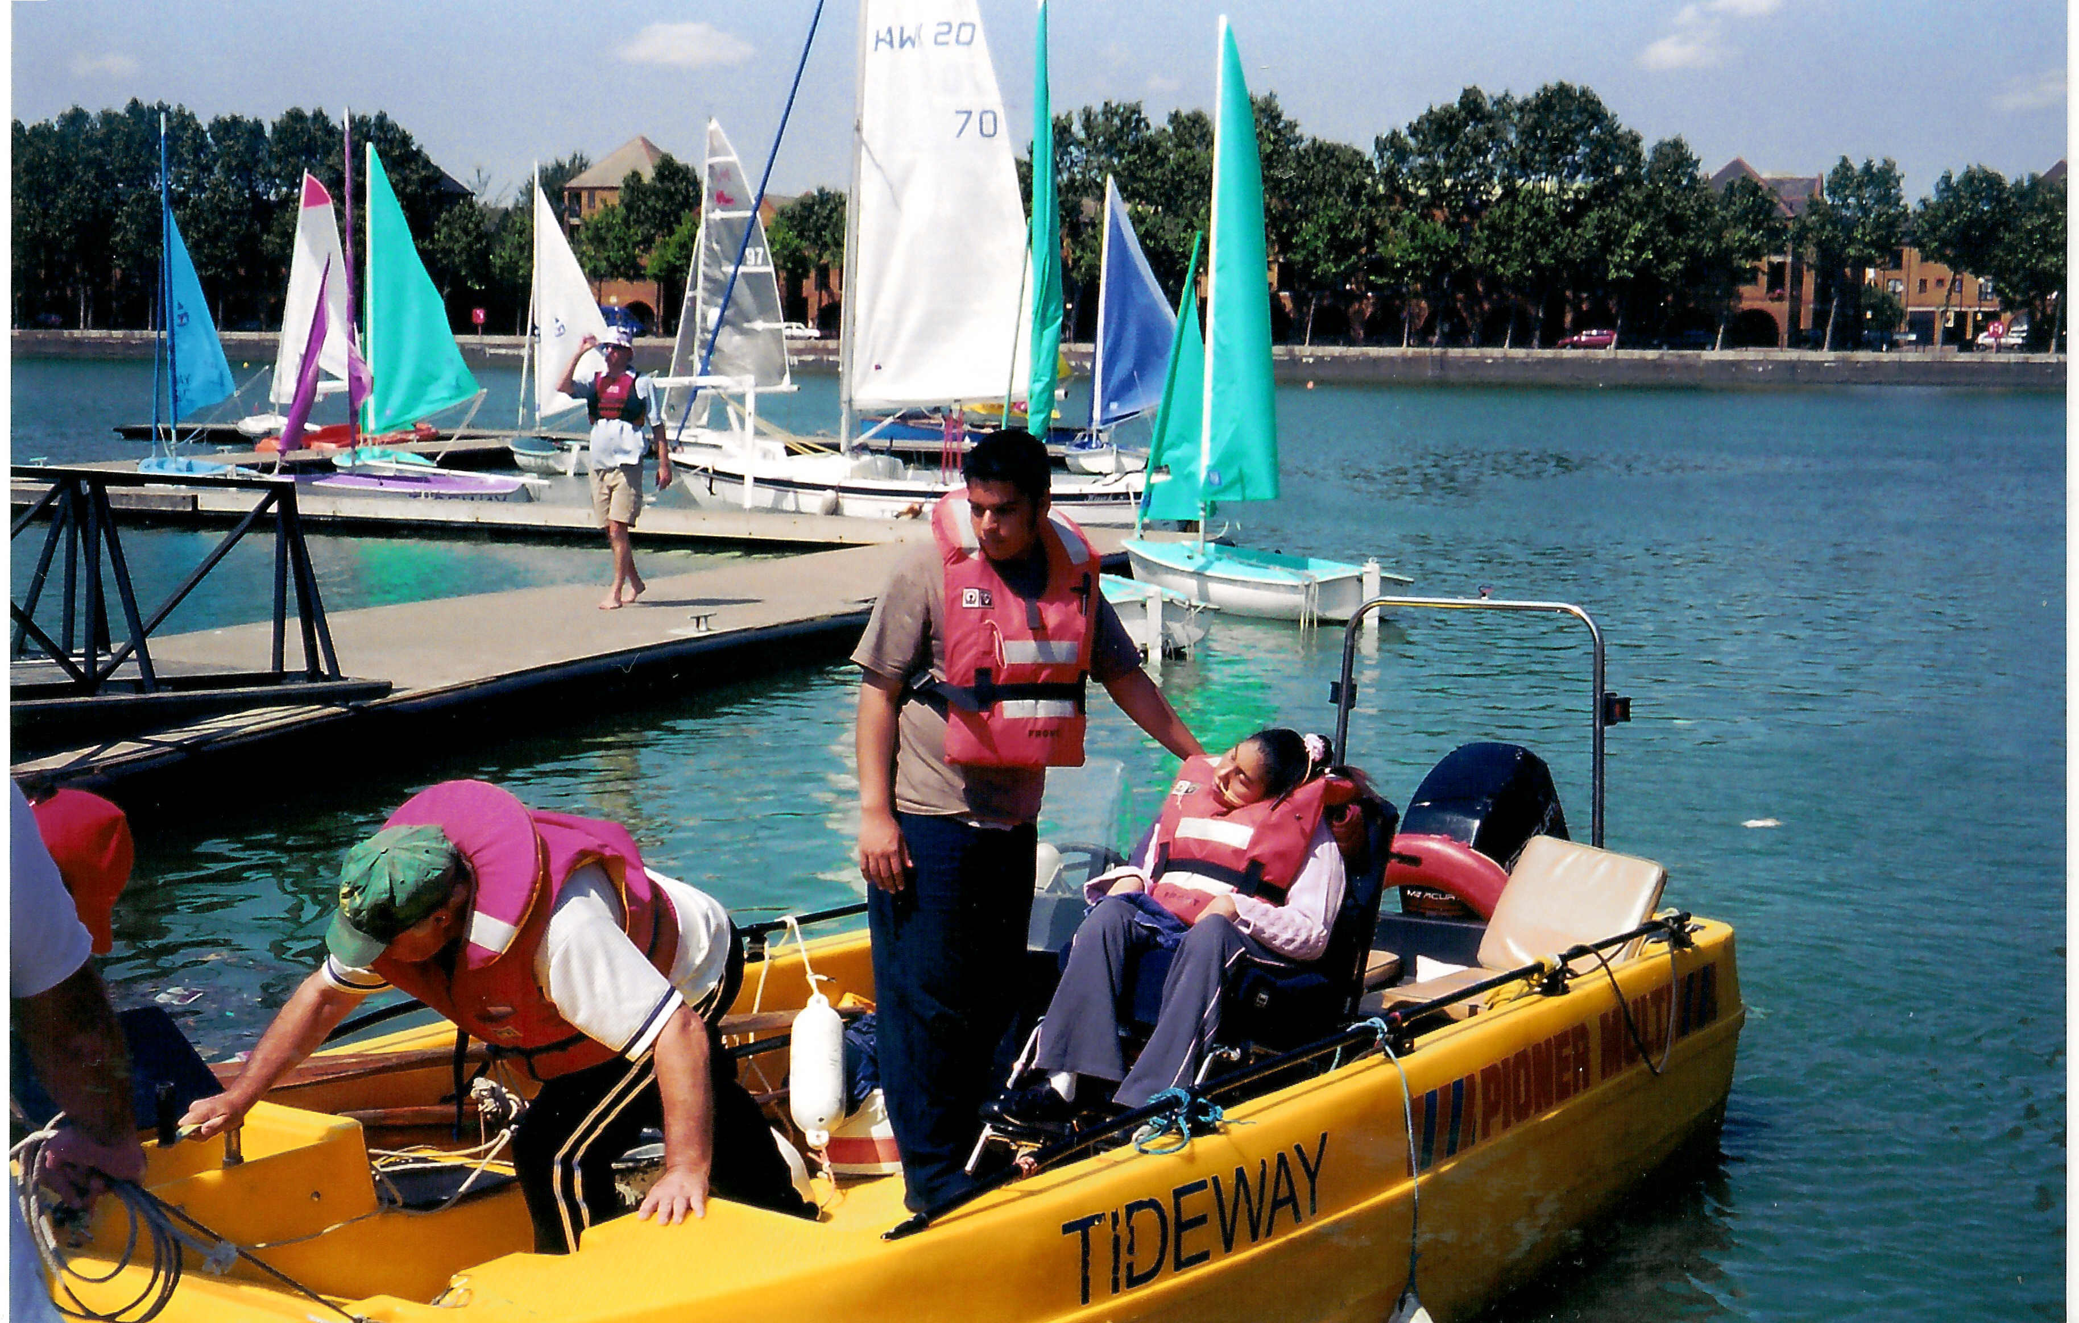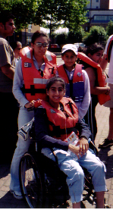

My Experience

As I have never experienced sailing it was a wonderful experience. It was a good day out. It should be a regular event. We should have made a video. We should have a sailing club for disabled people. The instructor was very supportive, he made me feel very confident. It gave me a sense of freedom. I wish I had stayed longer.

by Jagdeep Rait

The second trip was to attend the Boccia Regional Championships that were held in Farnborough Sports Centre. This was an excellent opportunity for members to see Boccia being played at a professional level.

PACE-ing Forward

Each member of PACE, whether disabled or non-disabled, feels a sense of personal development since attending the club. Recently, five members showed an interest in training to lead sessions within PACE. Tim from LSF delivered a training programme for these members who had displayed key skills required for leading a sports session. The first half of the training, consisted of theory work involving the importance of warm ups and their physical and psychological benefits. The practical aspects included building on foundation skills by working on one’s own, with a partner and in a team. The second half of this training will be taking place in July 2005. The training will equip team leaders in coaching skills enabling them to effectively lead sessions for groups of all abilities.

Other training that we need to consider for some our members, in particular, the support workers, is in the areas of health and safety and manual handling.

We have built strong links with LSF, Active Ealing and the Heston Community Centre. They have loaned PACE with sports equipment, practical advice and support. PACE needs to build links with other similar clubs with a view to holding competitions and perhaps creating some kind of league structure.

We need to secure funding for PACE to enable us to continue meeting this great demand from the community. We are currently looking at various funding bodies that may help us to do this.

Membership of PACE has grown considerably during the year. We began our club with twelve disabled young people and

Information on current membership, ethnicity, disability, age, sex

The first year of PACE has seen it develop from a small club where young disabled people were given an opportunity to express themselves freely and were taken seriously in what they said. Parents of disabled children have been given an opportunity to network with other parents in a more structured environment, exchanging valuable information that will offer them and their disabled children more freedom to make their own choices in life. We realise there is still a great deal of work to be done with parents and young disabled people to attempt to eradicate discrimination, prejudice and the stereotyping of disability from within society and culture.

The last three years have been a learning curve for all of us, the parents of disabled children and young disabled people. That section of the community

Recommendations

A special school.

