REAL PEOPLE, REAL LIVES
A Pack Exploring Disability Equality

Published by
Disability Equality In Education
© Copyright Disability Equality In Education & Newham Primary Care Trust June 2004

Written by
Michelle Daley

Photographer
Christopher Taylor

Designer
Caroline Grimshaw

Contents

Acknowledgements

Introduction

Teacher Notes
- About the Lesson Pack
- How to use the pack
- Personal, Social and Health Education - National Curriculum
- Key Stage 2
- Key Stage 3

- Putting Disability into Context
- What is Disability?
- What are the Models of Disability?
- Medical Model of Disability
- Social Model of Disability
- Disability Discrimination Act 1995 - Overview
- Language and Terminology
- What is Citizenship?

Lesson Activities
- Section A - How Images Inform Our Thinking
- Section B - The Power of Language and Images.
Does it really matter?
- Section C - How can the law help to create inclusion?

Resources

Acknowledgement

Congratulations to Martin Cunnington and his staff for giving Disability Equality in Education the opportunity to work on such an exciting and inspiring project. Many thanks to all of the individuals for their hard work, commitment and dedication that saw the project through to completion.

Thanks to Disability Equality in Education staff and trainers:

- Richard Rieser
- Christine O’Mahony
- Andy Ball
- Jaspal Dhani
- Laura Chapman
- Andrew Hodgson
- Maresa MacKeith
- Micheline Mason
- Tam Preboye
- Nancy Maguire
- Nazeem Safder

Thanks to individuals who agreed to be photographed and to their parents for their support:

- Emmanuel Bugembe
- Hajinder and Lakhvinder Singh and their brothers and sisters
- Irfan Jamal
- Jamal Hussein
- Jonathan Orphan
- Jordan Andrew
- Murad Shaikh, pupils, and staff of Sir John Heron Primary School – Newham
- Raiders - Wheelchair Basketball Team
- Saifur Valli and Staff at Newham Voluntary Service
- Tam Preboye

Introduction

The Project
In July 2003, Disability Equality in Education (DEE) was asked by Newham Primary Care Trust to carry out an exercise to explore disability equality in the London Borough of Newham. During a very productive discussion at the Newham Child Development Centre Open Day in March 2002, a number of parents said that they were fed up with people staring at their children. They were fed up with people not having an understanding of their child’s needs, or tutting when their child did something that may not be perceived as normal behaviour. This led to the development of the inter-agency steering group on disability awareness.
Martin Cunnington

The project was given the title, “INCLUSION WHERE IT’S @...”.

The aim was to:
- Hold five Disability Equality Training courses across the London Borough of Newham for voluntary organisations, community groups, social workers, school staff and Early Years professionals.
- Hold a One Day Conference on Inclusion of disabled people, for anyone who works with disabled children, including parents.
- Produce a pack of positive images of disabled people going about their everyday lives to be used as part of the Citizenship Curriculum in schools.

Disability Equality in Education – who are we?
DEE is a small fast-growing charity that provides training and consultancy work on including disabled people in mainstream education. Our work is exciting, dynamic, thought provoking and challenging. All work is carried out by highly experienced Disabled Trainers and is based on the Social Model of Disability. The philosophy behind this model is that the barriers in environment, attitude and organisation are the problem, rather than disabled people’s Impairments.
For more information about DEE, go to our website on www.diseed.org.uk.

The London Borough of Newham
Newham is renowned for its good work in inclusion and has led the way in terms of inclusion in mainstream education. Newham is committed to ensuring that all disabled children in the Borough have a right to be in mainstream education. They adopted the Social Model of Disability in 1995 and have made it part of the Borough’s Equality policy.

Newham recognises that there are gaps in their service provision, especially in the promotion of positive images of disabled people. It is for this reason that DEE was asked to produce this pack.
Teacher Notes

What Is Citizenship?

The key principle of the Citizenship Curriculum is to provide pupils with the ‘knowledge, skills and understanding’ needed to take part in society at local, national and international level.

This will be achieved by promoting pupils’ ‘spiritual, moral, social and cultural development’. It will help them to have a broader outlook by providing an awareness of social and moral issues found in everyday life and in society today.

“Education in citizenship and democracy will provide coherence in the way in which all pupils are helped to develop a full understanding of their roles and responsibilities as citizens in a modern democracy. It will play an important role, alongside other aspects of the curriculum and school life, in helping pupils to deal with difficult moral and social questions that arise in their lives and in society.”

Rt Hon David Blunkett & Sir Williams Stubbs
– Citizenship (The National Curriculum for England, 1999)

According to the 2001 census 17% of the UK population are disabled people.

About the Lesson Pack

This Lesson pack is aimed at Key Stages 2 and 3 and is based on the 20 images enclosed. Further reading and notes show where it fits into the National Curriculum (see The Personal, Social and Health Education – National Curriculum). All images include disabled people covering everyday activities, for example employment and family life.

The Pack looks at the representation of disabled people in society. Traditionally, the portrayal of disabled people in literature, art, film and other media has been very negative. This reinforces stereotyped attitudes towards disabled people. It is hoped that this pack will challenge pupils’ prejudices, stereotyped ideas and misconceptions. The aim is for all young people to have a rational understanding of the term disability.

The pack includes the following items:
- 20 A4 picture cards
- 5 A3 posters
- CD ROM, containing:
      - 20 A4 Posters
      - 5 A3 Cards
      - Text version of the guide.

How to use the pack
Before attempting any of the activities with your pupils, it is recommended that you become familiar with the supporting information:
- The Medical and Social Models of Disability
- Use of appropriate language when discussing disability/disabled people
- The Disability Discrimination Act 1995

Your role will be to give pupils an insight into the medical and social models of Disability and the impact they have on thinking and attitudes towards disabled people.

Your aim will be to demonstrate the considerable impact the media has on our thinking and how it can reinforce prejudicial views and lead to discrimination.

The teacher should gain an idea of the initial perception of their pupils about disability issues at the start of the activity. The final unit is to ask the pupils to write about how their attitudes about disability have changed since doing this lesson.
You could set an activity whereby the pupils are asked where they would like the posters to be displayed in the school. It is important that the whole school is able to access these images.

Pupils should become informed about:
- the impact the media has in reinforcing stereotypes with the use of text
- how the media defines ‘normal’ and ‘abnormal’ (i.e. different people)
- where our views about disability come from
- how to portray disabled people without becoming offensive or reinforcing stereotypes
- the medical and social models of disability
- the difference between impairment and disability and how it is viewed by society
- correct use of terminology when referring to disabled people
- a basic understanding of disability legislation
- discriminatory barriers that exclude disabled people and how to remove them
- how using the Social Model of Disability will lead to full inclusion of all individuals

The Personal, Social and Health Education – National Curriculum

Key Stage 2
Developing good relationships and respecting the differences between people.

Subject | Learning outcome
PSHE/Citizenship | 1a Talking and writing about their opinions, and explaining their views  2a Researching, discussing and debating topical issues, problems and events  2e Reflecting on spiritual, moral, social and cultural issues, using imagination to understand other people's experiences
English | En 1/3: Speaking and listening: group discussion and interaction
ICT | 5b Working with others to explore a variety of information sources

Key Stage 3
Pupils study, reflect upon and discuss topical political, spiritual, moral, social and cultural issues, problems and events. They learn to identify the role of the legal, political, religious, social and economic institutions and systems that influence their lives and communities. They continue to be actively involved in the life of their school, neighbourhood and wider communities and learn to become more effective in public life. They learn about fairness, social justice, respect for democracy and diversity at school, local, national and global level, and through taking part responsibly in community activities.

Subject | Learning Outcome
PSHE/Citizenship | History 2b: knowledge and understanding of events, people and changes in the past  1h the significance of media in society  3a to use imagination to consider other people’s experiences  3b negotiate, decide and take part in both school and community based activities  3c the process of participation
English | En1d Speaking and listening: use visual aids to enhance listening  En3 1i Writing: develop logical arguments and cite evidence  En3 3 Speaking and listening: group discussion and interaction
ICT | 2b Email to exchange ideas

Putting Disability into Context

What is Disability?
How do we make sense of the word disability when we use different definitions?

Disability is still misunderstood by many people in society today. Much of our understanding comes from our history and feelings about disabled people. This has led to incorrect thinking about the lives of disabled people. For centuries disabled people have been segregated and marginalised from mainstream society, having a small role to play in society or the community at large. Disabled people began to resent this form of treatment and were no longer prepared to live in such discriminatory conditions. In the 1960s we saw the birth of the International Disability Movement which began to challenge and campaign against the oppression and segregation.

What are the Models of Disabilities?
In order to help clarify your understanding of disability, you need look at the Medical and Social models of disability.
The Models of Disability are useful tools for defining and understanding impairment and disability issues. In addition, you will gain the perspectives held by those creating and applying the models.
The Models question our understanding about disability and provide an insight into the way in which society views people with Impairments. What the Models do is to bring to light what influences our decisions, where attitudes come from and who has the political power.

The Medical Model says disabled people need specialist care / services and are dependent on society. The Social Model shows discriminatory barriers in our society, which excludes disabled people from fully participating. The underlying principle for using these Models will be for recognising disability discrimination and finding the solution to create inclusion and give disabled people full and equal rights alongside their fellow citizens.

1. Medical Model of Disability
The Medical model of disability looks at disability as being caused by the results of individual physical, sensory and/or mental limitations that prevent the person from fully participating in society. This Model places the basis of the problem on the individual and concludes that solutions are found by focusing on the individual impairment and by trying to help the individual overcome their personal impairment. In this Model, the process will be to seek a cure to make disabled people “normal”.

The definitions used in this model have been devised by the World Health Organisation’s Classification of Impairments, Disabilities and Handicaps, 1980:

- Impairment: any loss or abnormality of psychological or anatomical structure or function.

- Disability: any restriction or lack of ability (resulting from an impairment) to perform an activity in the manner or within the range considered normal for a human being.

- Handicap: any disadvantage for a given individual, resulting from impairment or a disability that limits or prevents the fulfilment of a role that is normal for that individual.

The Medical Model of Disability

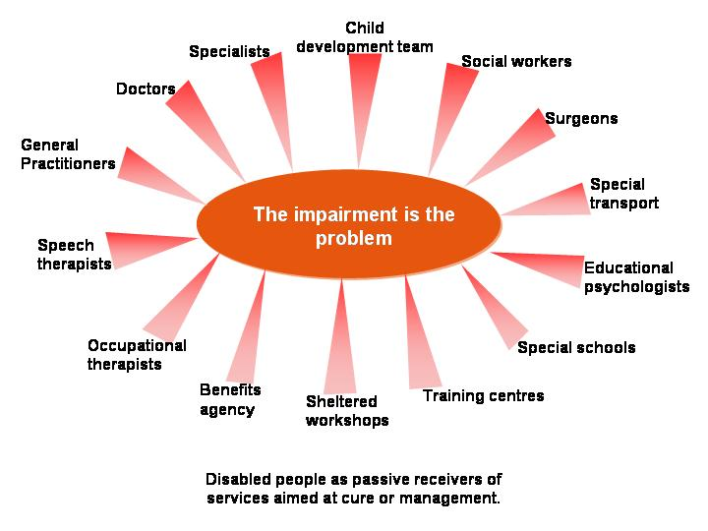

2. Social model of Disability
In order to achieve equality and get to a position of inclusion whereby everyone has equal access to mainstream activities, the Social Model of Disability requires society to analyse and change its values and practices. By indentifying the barriers which result in discrimination, society can seek solutions to remove that barrier.

Disabled people began challenging society to give up the idea that disability is a medical problem requiring "treatment". Disabled people want people to understand that disability is to do with the built enviroment, people’s attitudes and structures within organisations that fail to recognise or take account of the needs of disabled people.

The definitions used in this model are:

Impairment – the loss or limitation of physical, mental or sensory function on a long term or permanent basis. (Disabled People’s International 1981)

Disability – the loss or limitation of opportunity to take part in the normal life of the community on an equal level with others due to physical and social barriers (Disabled People’s International, 1981)

The Social Model of Disability
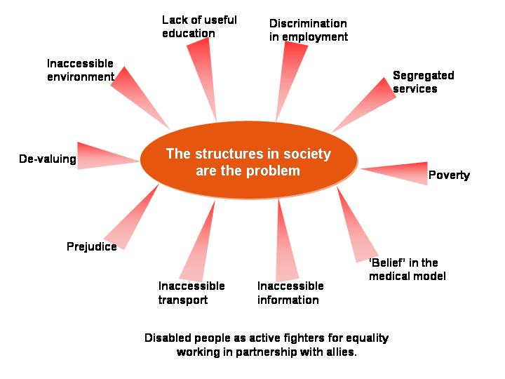

Disability Discrimination Act 1995 – An overview

The Disability Discrimination Act came into force 1996. Its aim is to remove discrimination faced by disabled people in the following areas:

- Employment – for example the employer must ensure that all disabled employees:
    - Have access to training
    - Have equal access to promotion
    - Have access to a fair recruitment practice

- Goods services and facilities – service providers must ensure that their services do not discriminate against disabled people:
    - By ensuring that information is produced in a range of formats
    - By having policies that do not discriminate
    - Ensuring venues have access for disabled people

- Education – in September 2002, the Special Educational Needs and Disability Act 2001 came into force. This required all educational establishments to ensure that they do not discriminate against disabled people with regard to:
- The way the curriculum is delivered
- The whole life of the educational establishment
- Access to admission and enrolment
- Exclusion

Draft Disability Bill
The draft Disability Bill is likely to become law later this year. The bill will amend and extend the Disability Discrimination Act 1995 in a number of ways. The main emphasis will be to introduce a new duty on all public bodies to promote disability equality.

Language and Terminology

USE / PREFERRED | AVOID / OFFENSIVE
Person who has  Person with  Person who experienced | Victim of
Disabled person  Person who has  Person with | Crippled by
Person who has  Person with | Sufferer  Suffering from
Person who has  Person with | Afflicted  Afflicted by
Wheelchair user | Wheelchair bound
Disabled person | Invalid
Disability / impairment | Handicap
Disabled person | Handicapped person / Person with a disability
Condition / impairment | Disability
Someone with cerebral palsy | Spastic
Disabled people | The disabled
Blind person  Visually impaired | The blind
Deaf people | The deaf
Deaf or deafened  Hearing impaired | Deaf and dumb  Deaf mute
Someone with Downs Syndrome or  Learning Difficulty | Mongol
Learning Difficulty | Mental handicap
Learning Difficulty | Retard / idiot / imbecile / feeble-minded
Speech difficulty | Mute / dumb / dummy
Mental Health System User/Mental health survivor | Mad / crazy / insane
Mental Health Survivor or system user | Mentally ill
Disabled person | Mental
Foolish / thoughtless | Stupid
Short person  Short stature | Dwarf  Midget
Disfigured | Deformed
Disabled Person | Congenital
Accessible toilet | Disabled toilet

LESSON ACTIVITES

Inclusion is a basic Human Rights issue and everyone needs to have a basic understanding of what it means. “All human beings are born free and equal in dignity and rights." Universal Declaration of Human Rights

Key Facts and Figures
(Source: Labour Force Survey (LFS) Summer 2002 - Great Britain)

- 47% of disabled people of working age are employed, as opposed to 74% of non-disabled people of working age

- Employment rates vary between types of impairments: they are lowest for those with mental health problems and learning difficulty

- Disabled people are twice as likely as non-disabled people to have no qualifications

- Less than 5% of disabled people use wheelchairs

Section A - How Images Inform Our Thinking

Learning objectives:
- to understand how the media can reinforce stereotypes
- to introduce the topic of the media and language
- to illustrate positive images of disabled people in everyday situations

Teachers’ objectives:
Pupils should be able to give at least:
- 2 examples of how images are used by the media to reinforce stereotypes
- 2 reasons why it is important to represent disabled people positively
- 2 examples of how the medical and social model is used by the media

Activities:
- Put all or selected images on the wall and ask the pupils to write positive headlines for each image.

- Ask pupils to skim through the images and select the image which appeals to them the most. Ask them why they chose that picture.

- Ask pupils to think about the impression created in the pictures they have selected:
- Are they aggressive?
- Are they powerful?
- Do they play with your emotions?
- Are they pitiful?

- Put the pupils in groups and get them to select one image from the wall. The task is for the pupils to imagine they are journalists and to write an article for the images. (Pupils may need support for writing an article, for example with the layout).

- Ask the pupils to think about how many disabled people they have seen in the media in the last week in:

    - Television programmes
    - Newspaper
    - Magazine
    - Films
    - Cinema
    - Bill boards
    - Adverts

How the Disabled Person was portrayed:
- What was their role?
- Was it positive or negative, why?
- How did they feel about the way the Disabled Person was shown?
- Why do they think the Disabled Person was displayed in that situation?

- Ask pupils to give to 1 or 2 examples of how the media uses images to promote the medical model of disability. Then ask the pupil to give 1 or 2 examples of how the media could use the social model to promote positive images of disabled people.

- Summary
Ask the pupils what have they learned from this activity.
How do they now feel about articles they see about disabled people?

Section B - The power of language and images. Does it really matter?!

Learning objectives:
- introduce the importance of using positive terminology
- how language can reinforce stereotypes and be offensive
- to explore the power of words
- to introduce the topic of the media and language

Teachers’ objectives:
Pupils should be able to give at least:
- 2 examples of how language used by the media can reinforce stereotypes and why they are used
- 1 positive script, caption, etc
- 1 example of why the medical and social model is used by the media

Activities:
- Ask the pupils to write down all the words that they think relate to disabled people:
- get the pupils to divide the words into negative and positive groupings and explain why they have put them into these groupings
- think about where these words would be used and why
- think about the impression these words give about disabled people
- what impact does the use of these words have

Then ask the pupils to use the images to do one of the following:
- write positive captions for the images
- design a positive logo
- design a media campaign on the importance for having positive images of disabled people

- This activity can be carried out in groups. The task is to get pupils to say whether their work reflects the medical or social model of disability, and why.

- Get the pupils to act out a drama scene, for example “a conversation between 3 people, where one of the people has an impairment and is being ignored”. Use freeze frame to stop the drama to discuss what is going on.

Section C - How can the law help to create inclusion?

Learning objectives:
- to introduce the concept of legislation
- to introduce how the law can bring about positive change
- to explore the barriers to participation not only in Great Britain
- to introduce the concept of inclusion and how to make it work

Teachers’ objectives:
- pupils should be able to design or plan a product or service that is inclusive and/or accessible
- pupils should be able to give at least 2 examples of barriers that prevent disabled people from participating in mainstream society
- how to remove the barriers and create inclusion
- what is discrimination in relation to the Disability Discrimination Act

Activities
- You are part of a design team and you have been commissioned to produce an inclusive product or service. You have a tight deadline of 3 weeks with a set budget. The requirement is for you to design one of the following products:
- Design a children’s board game
- Design a range of sports clothing
- Design a music studio, office or sport centre
- Design a children’s play area

Each group will need to:
- produce a plan for your product and in your plan list what barriers could prevent individuals from using the product
- show how you have ensured that you considered the access needs of as many people as possible
- say why you have chosen this product and why you believe it to be an inclusive product

- Develop a discussion on how disability is portrayed in other parts of the world and what might be the barriers for disabled people in these countries? Try to use pupils’ own experience where possible.

For example, in terms of:
- access to equipment
- access to public transport
- access to employment
- access to education
- access to medical treatment
- taking part in family activities

- The Disability Discrimination Act aims to remove discrimination faced by disabled people in the following areas:
- Employment (work)
- Service providers, goods and facilities
- Education

Each pupil is to select one image and develop a campaign to promote the importance of the Disability Discrimination Act 1995. The pupil must also state in their campaign which part of the act they are referring to.

The kind of things you could get the pupils to do are:
- write to their local MP
- design a poster
- invite people to their class and question their approach on disability issues, for example access to leisure services
- set up a debate and get the pupils to chose the topic, for example should disabled people have the same right to access all transport services

Resources

Recommended reading/resource

- All Equal All Different by DEE and UK Disability Forum. This resource pack comes with various materials that can be used to promote equality in pre-school and primary settings. Available from DEE.

- All Together Better by Micheline Mason and Richard Rieser. A video aimed at promoting an understanding about disability issues. Available from DEE.

- DEE Catalogue of Resources. Available from DEE.

- Disability Equality in the Classroom by DEE. A resource book which contains activities to promote disability equality in the classroom. Available from DEE.

- Disabling Imagery. A teachers’ guide to disability and moving imagery media. By DEE and British Film Institute. Provides clear presentation disability used in the media. Available from DEE.

- Empower Video and Training Pack. By Connexions North London. Available from DEE.

- Making it Work – Removing Disability Discrimination. Are you ready? The Council for Disabled Children and DEE. A detailed description on the Special Education and the Disability Discrimination Act. Available from DEE.

Recommended websites

- Alliance for Inclusive - Education - www.allfie.org.uk

- British Film Institute - www.bfi.org.uk

- Disability Awareness In Action - www.daa.org.uk

- Disability Equality In Education - www.diseed.org.uk

- Disability Rights Commission - www.drc.gov.uk

- Disability Rights Promotion International www.yorku.ca/drpi/index.asp

- Disabled People International - www.dpi.org

- Inclusive solutions - www.inclusive-solutions.com

- Newham Council - www.newham.gov.uk

- National Centre For Independent Living - www.ncil.org.uk

- Newham Primary Care Trust - www.newhampct.nhs.uk

Useful Contacts

- Alliance for inclusive Education
Unit 2, 70 South Lambeth Road, Vauxhall, London SW8 1RZ
Tel: 020 7735 5277

- British Deaf Association
1-3 Worship Street London EC2A 2AB
Voice phone: 020 7588 3520 Fax: 020 7588 3527 videophone: 020 7496 9539 Email: helpline@bda.org.uk Text Phone: 020 7588 3529

- British Council Of Disabled People
Litchurch Plaza, Litchurch Lane, Derby DE24 8AA
Tel: 01332 295551

- Disability Equality in Education (DEE)
Unit GL, Leroy House, 436 Essex Road, London, N1 3QP
Tel: 020 7359 2855 Fax: 020 7354 3372

- Greater London Action on Disability
336 Brixton Road, London SW9 7AA
Tel: 020 7346 5800

- National Centre For Independent Living
250 Kennington Lane London SE11 5RD
Tel: 0207 587 1663 Fax: 0207 582 2469 Text: 0207 587 1177

- Royal National Institute of the Blind
105 Judd Street, London, WC1H 9NE
Tel: 020 7388 1266 Fax: 020 7388 2034

