MEDICAL MODEL / SOCIAL MODEL
DEFINITIONS
Impairment is the loss or limitation of physical, mental or sensory function on a long term, or permanent basis.
Disablement is the loss or limitation of opportunities to take part in the normal life of the community on an equal level with others due to physical and social barriers. Disabled People's International 1981)
Disabled People include people with: physical impairments; sensory impairments deaf people, blind people); chronic illness or health issues including HIV and AIDS; all degrees of learning difficulties and emotional and behavioral problems. It also includes people with hidden impairments such as epilepsy, diabetes, sickle cell anemia; specific learning difficulties such as dyslexia, speech and language impairments, children labeled as 'delicate'; people who identify as 'disfigured'; people of diminutive stature and people with mental distress. All are excluded by barriers though not all have impairments. Two Ways of viewing disablement: 'Medical Model' or 'Social Model'.

The 'Medical Model' of Disability
The 'medical model' sees the disabled person as the problem. We are to be adapted to fit into the world as it is. If this is not possible, then we are shut away in some specialised institution or isolated at home, where only our most basic needs are met. The emphasis is on dependence, backed up by the stereotypes of disability that call forth pity, fear and patronising attitudes.
Usually the impairment is focused on, rather than the needs of the person. The power to change us seems to lie within the medical and associated professions, with their talk of cures, normalisation and science. Often our lives are handed over to them.
Other people's assessments of us, usually non-disabled professionals, are used to determine where we go to school, what support we get and what type of education; where we live; whether or not we can work and what type of work we can do and indeed whether or not we are born at all, or are even allowed to procreate. Similar control is exercised over us by the design of the built environment presenting us with many barriers, thereby making it difficult or impossible for our needs to be met and curtailing our life chances. Whether it is in work, school, leisure and entertainment facilities, transport, training and higher education, housing or in personal, family and social life, practices, and attitudes disable us. Powerful and pervasive views of us are reinforced in the media, books, films, comics, art and language. Many disabled people internalize negative views of themselves that create feelings of low self-esteem and achievement, further reinforcing non-disabled people's assessment of our worth. The 'medical model' view of us creates a cycle of dependency and exclusion, which is difficult to break.
'Medical model' thinking about us predominates in schools where special educational needs are thought of as resulting from the individual who is seen as different, faulty and needing to be assessed and made as normal as possible.
If people were to start from the point of view of all children's right to belong and be valued in their local school we would start by looking at 'what is wrong' with the school and looking at the strengths of the child. This second approach is based on 'social model' of disability thinking which views the barriers that prevent disabled people from participating in any situation as what disables them. The social model arises from defining impairment and disability as very different things.

The 'Social Model' of Disability
Impairment and chronic illness exist and they sometimes pose real difficulties for us. The Disability Movement comprises those disabled people and their supporters who understand that they are, regardless of their particular impairment, subjected to a common oppression by the non-disabled world. We are of the view that the position of disabled people and the discrimination against us are socially created. This has little to do with our impairments. As a disabled person you are often made to feel it's your own fault that you are different. The difference is that some part,or parts, of your body or mind are limited in their functioning. This is an impairment. THIS DOES NOT MAKE YOU ANY LESS OF A HUMAN BEING. But most people have not been brought up to accept us as we are. Through fear, ignorance and prejudice barriers and discriminatory practices develop which disable us. The understanding of this process of disablement allows disabled people to feel good about themselves and empowers us to fight for our human rights.
The Disabled People's Movement believes the 'cure' to the problem of disability lies in the restructuring of society. Unlike medically based 'cures', which focus on the individual and their impairment, this is an achievable goal and to the benefit of everyone. This approach referred to as the 'social model' suggests those disabled people's individual and collective disadvantage is due to a complex form of institutional discrimination as fundamental to our society as sexism, racism or heterosexism.
In addition to this, the obsession with finding medically based cures, distracts us from looking at causes of either impairment or disablement. In a worldwide sense, most impairments are created by oppressive systems - hunger, lack of clean water, exploitation of labour, lack of safety, child abuse and wars.
Clearly, this thinking has important implications for our education system, particularly with reference to primary and secondary schools. Prejudicial attitudes toward disabled people and, indeed, against all minority groups, are not inherited. They are learned through contact with the prejudice and ignorance of others. Therefore, to challenge discrimination against disabled people we must begin in our schools.
Our fight for the inclusion of all children, however 'severely' disabled, in one, mainstream, education system, will not make sense unless the difference between the 'social' and the 'medical' or individual model of disability is understood.
The Medical Model.
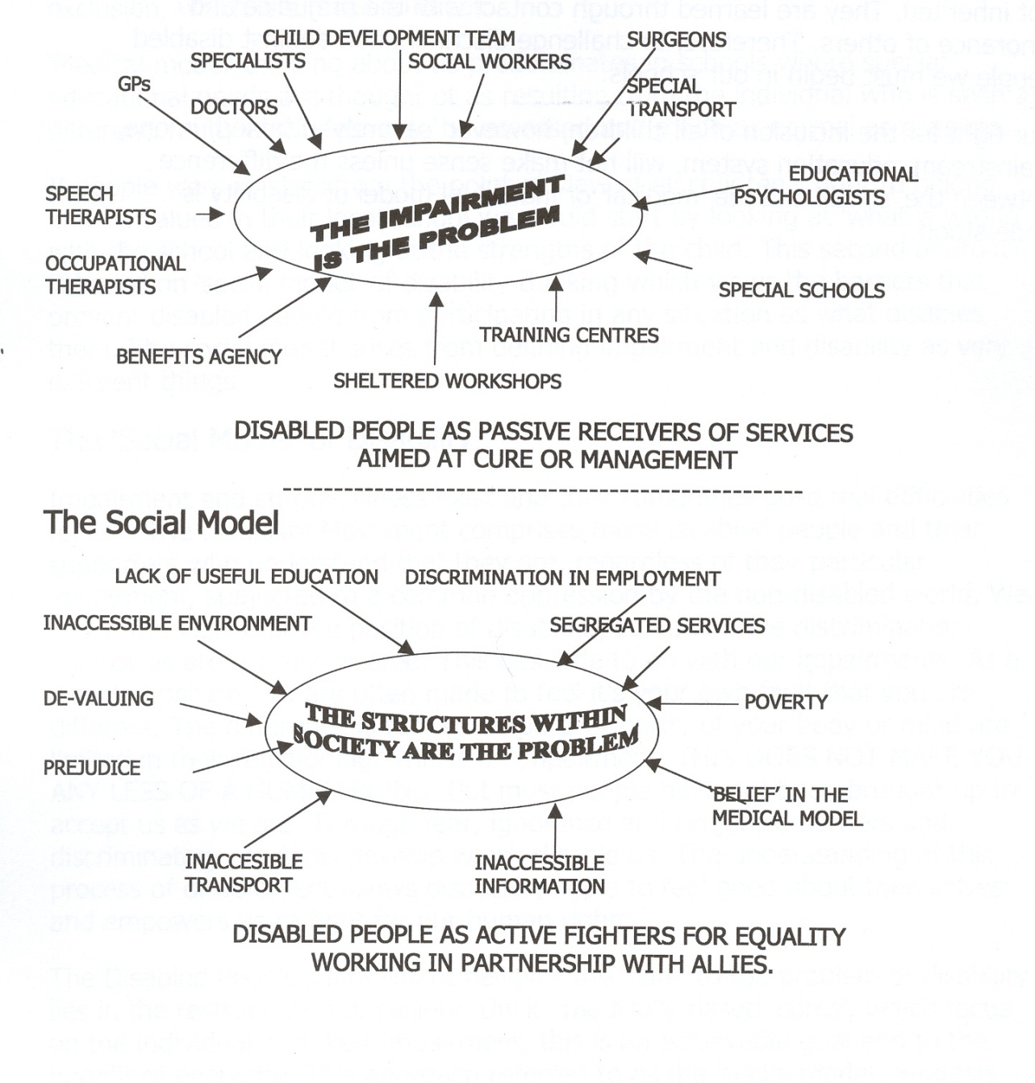

MEDICAL / SOCIAL MODELS
Medical And Social Model Thinking In Schools
MEDICAL MODEL THINKING | SOCIAL MODEL THINKING
Child is faulty | Child is Valued
Diagnosis | Strengths and Needs defined by self and others
Labeling | Identify Barriers and develop solutions
Impairment becomes Focus of attention | Outcome based programme designed
Assessment, monitoring, programmes of therapy imposed | Resources are made available to Ordinary services
Segregation and alternative services | Training for Parents and Professionals
Ordinary needs put on hold | Relationships nurtured
Reentry if normal enough OR Permanent Exclusion | Diversity Welcomed, Child is Included
Society remains unchanged | Society Evolves

